













































































































































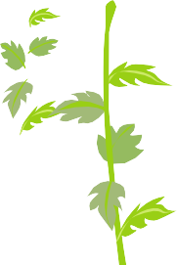


















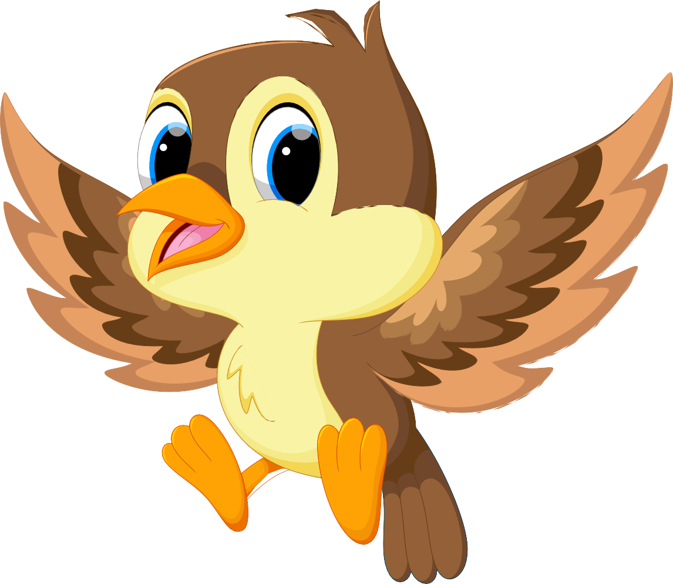
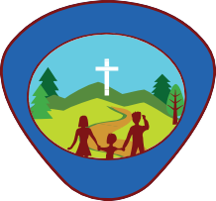

Activity Book
Early Bird

This book belongs to
L
T
C
U
R
E
R
A
D
V
E
B
U
N

General Conference Youth Ministries Department

Early Bird
Activity Book

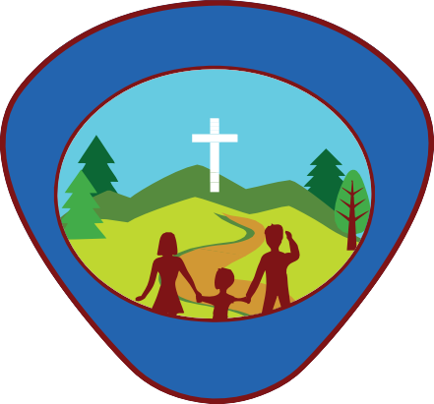
General Conference Youth Ministries Department
L
T
C
U
R
E
R
A
D
V
E
B
U
N

Produced by:
General Conference Youth Ministries Department 12501 Old Columbia Pike
Silver Spring, MD 20904

Departmental Director: Gary Blanchard Associate Youth Director: Pako Mokgwane Associate Youth Director: Andrés J. Peralta Editor-in-Chief: Andrés J. Peralta Departmental Advisor: Abner De Los Santos Senior Editorial Assistant: Kenia Reyes-de León

Project Manager: Mark O’Ffill
Content Contributors: Mark O’Ffill
Ted & Betsy Burgdorff

Copy Editor: Mark O’Ffill

Cover & Interior Designer:
Jonatan Tejel Isaac Chia
Adrian Gutierrez Perez Wilbert Hilario (ClicArt) Had Graphic Inc. hadgraphic@gmail.com
Photos by: © Shutterstock Resources:
Gomez, Ada. “Adventist Adventurer Awards.” Adventist Ad- venturer Awards - Wikibooks.org. North American Division Club Ministries, 2014. Web. 26 July 2017. <https://en.wiki- books.org/wiki/Adventist_Adventurer_Awards>.

Gooch, Jennifer A. Eager Beaver Leader’s Guide with 23 Themed Meeting Plans. 3rd ed. Lincoln, Neb.: Advent- Source, 2007, 2015. Print.

For information
Email: youth@gc.adventist.org Website:
youth.adventist.org

Early Bird Checklist

Name: Date Started: Date Completed:

Basic Requirements
My Family
Instructor Checklist

- Recite the Adventurer Law
- Complete the Story Listening II award
- Complete the Birds award
My God
- God’s Plan to Save Me
  - Colour a story chart or lapbook about the people in the Bible who prayed:
Samuel, Daniel, Jonah, David
  - Learn how to pray independently
  - Earn the Jesus Star award
- God’s Message to Me
  - Complete the Bible Friends II award
- God’s Power in My Life
  - Have a regular family worship time in your home. Keep a record
  - Ask someone you know why they pray
  - Complete the God’s World award
My Self
- I Am Special
  - Complete the Left & Right award
- I Can Make Wise Choices
  - Complete the Manners Fun award
- I Can Care for My Body
  - Complete the Know Your Body award
- I Have a Family
  - Say the fifth commandment: “Honour your father and your mother” (Exodus 20:12)
- Families Care for Each Other
  - Complete the Helping at Home award
- My Family Helps Me Care for Myself
  - Complete the Fire Safety award
My World
- The World of Friends
  - Complete the My Community Friends award
- The World of Other People
  - Complete the Playing with Friends award
- The World of Nature
  - Complete the Scavenger Hunt award The World of Nature
- Other awards that may be earned by Early Birds include:
- Alphabet Fun
- Animal Homes
- Animals
- Beginning Biking
- Beginning Swimming
- Birds
- Crayons & Markers
- Gadgets and Sand,
- Jigsaw Puzzle,
- Pets.
Basic Requirements
1.
2.
3.
My God
1.
a.
b.
2.
a.
3.
a.
b.
c.
My Self
1.
a.
2.

a.
3.

a.
My Family
1.
a.
2.
a.
3.
a.
My World
1.
a.
2.
a.
3.
a.


Recite the Adventurer Law
1

Jesus can help me to:
Be obedient Be pure Be true Be kind
Be respectful
Be attentive Be helpful
Be thoughtful Be reverent
Adventurer Law

Date completed ________________

Counselor’s Signature __________________

Complete the Story Listening II award
2

- Listen to two age-appropriate books, not read before, from the following categories:
  - Bible

Date Completed _________________
Counselor’s Signature _________________________

  - Missions
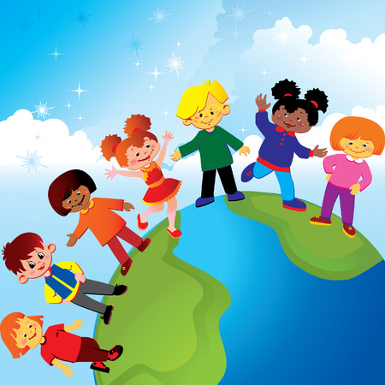

Date Completed _____________________
Counselor’s Signature _______________________________

  - Friends or family


Date Completed _______________________
Counselor’s Signature __________________________

  - Nature
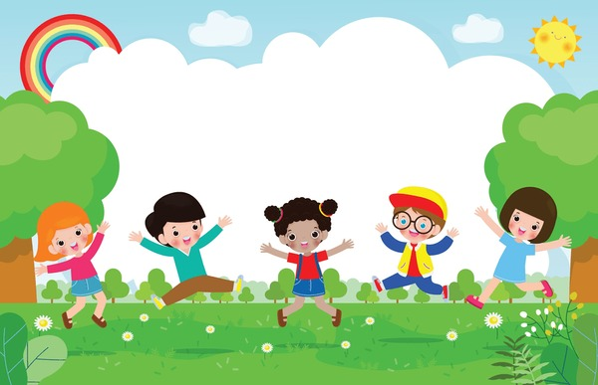

Date Completed _______________
Counselor’s Signature ______________________

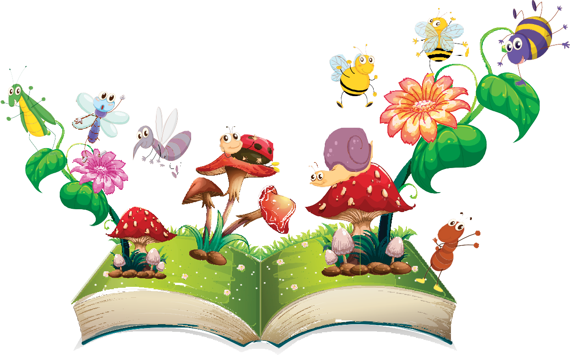

- Tell the person who read to you what you like most about each story. Be sure to tell them something about the main “character” in each story. (Note taking area for adult care givers).

- _____________________________________________________________

- _____________________________________________________________
- _____________________________________________________________




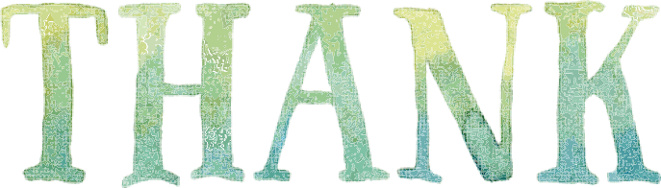







- Tell the person who read to you “thank you” OR make a craft that you give them that tells them you are thankful. Place picture of craft item.







The Birds award
2

- Name five birds you can see around your home. (Note taking area for adult care givers)
Place pictures of birds seen in the box below.

- Name the official bird of your region, province, state or country. (Note taking area for adult care givers). Place picture of bird in the box below.

- Name three kinds of foods birds eat.

- Using a picture of a bird, use a mixture of bird seeds to fill it in to make a bird-seed decoration.

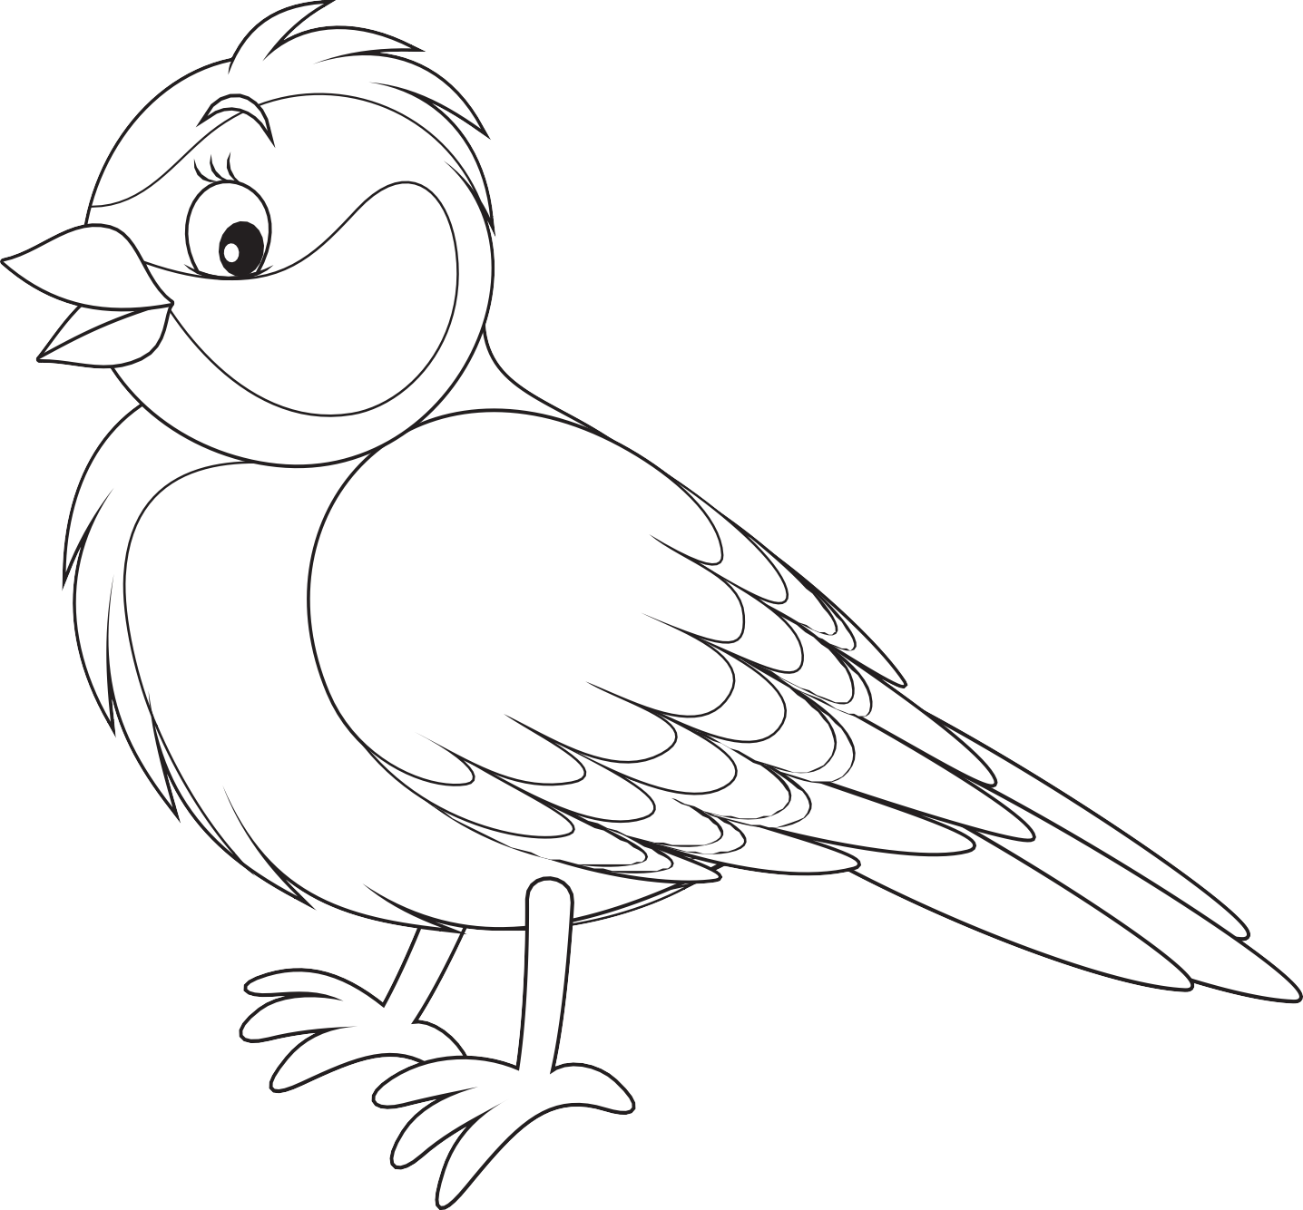

- Make a bird feeder and hang it outside where you can see it. Count how many birds come to feed from it. Place picture of bird feeder you made.

- Tell two bible stories that mention a bird. (Note taking area for adult care givers)

______________________________________________________________
______________________________________________________________
______________________________________________________________
- Know two bird sounds and pretend you are that bird. (Note taking area for adult care givers)

- Read a book or watch a media clip about a bird(s) you might be able to see in the wild.
Write briefly what you read or watch (Note taking area for adult care givers)

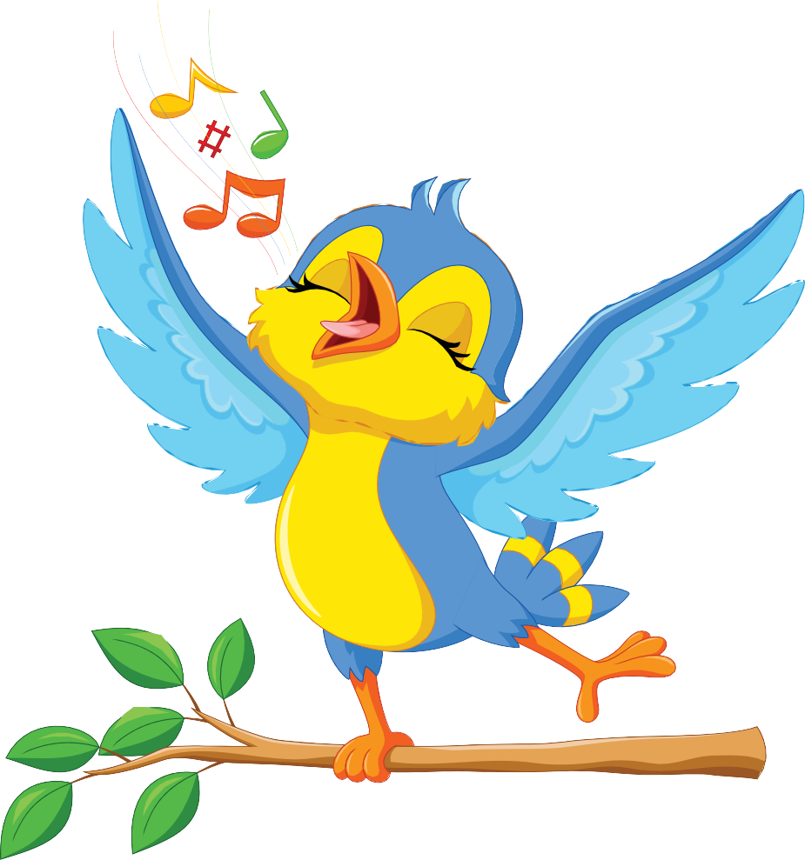

Colour a story chart or lap-book about people in the Bible who prayed: Samuel, Daniel, Jonah, David
1

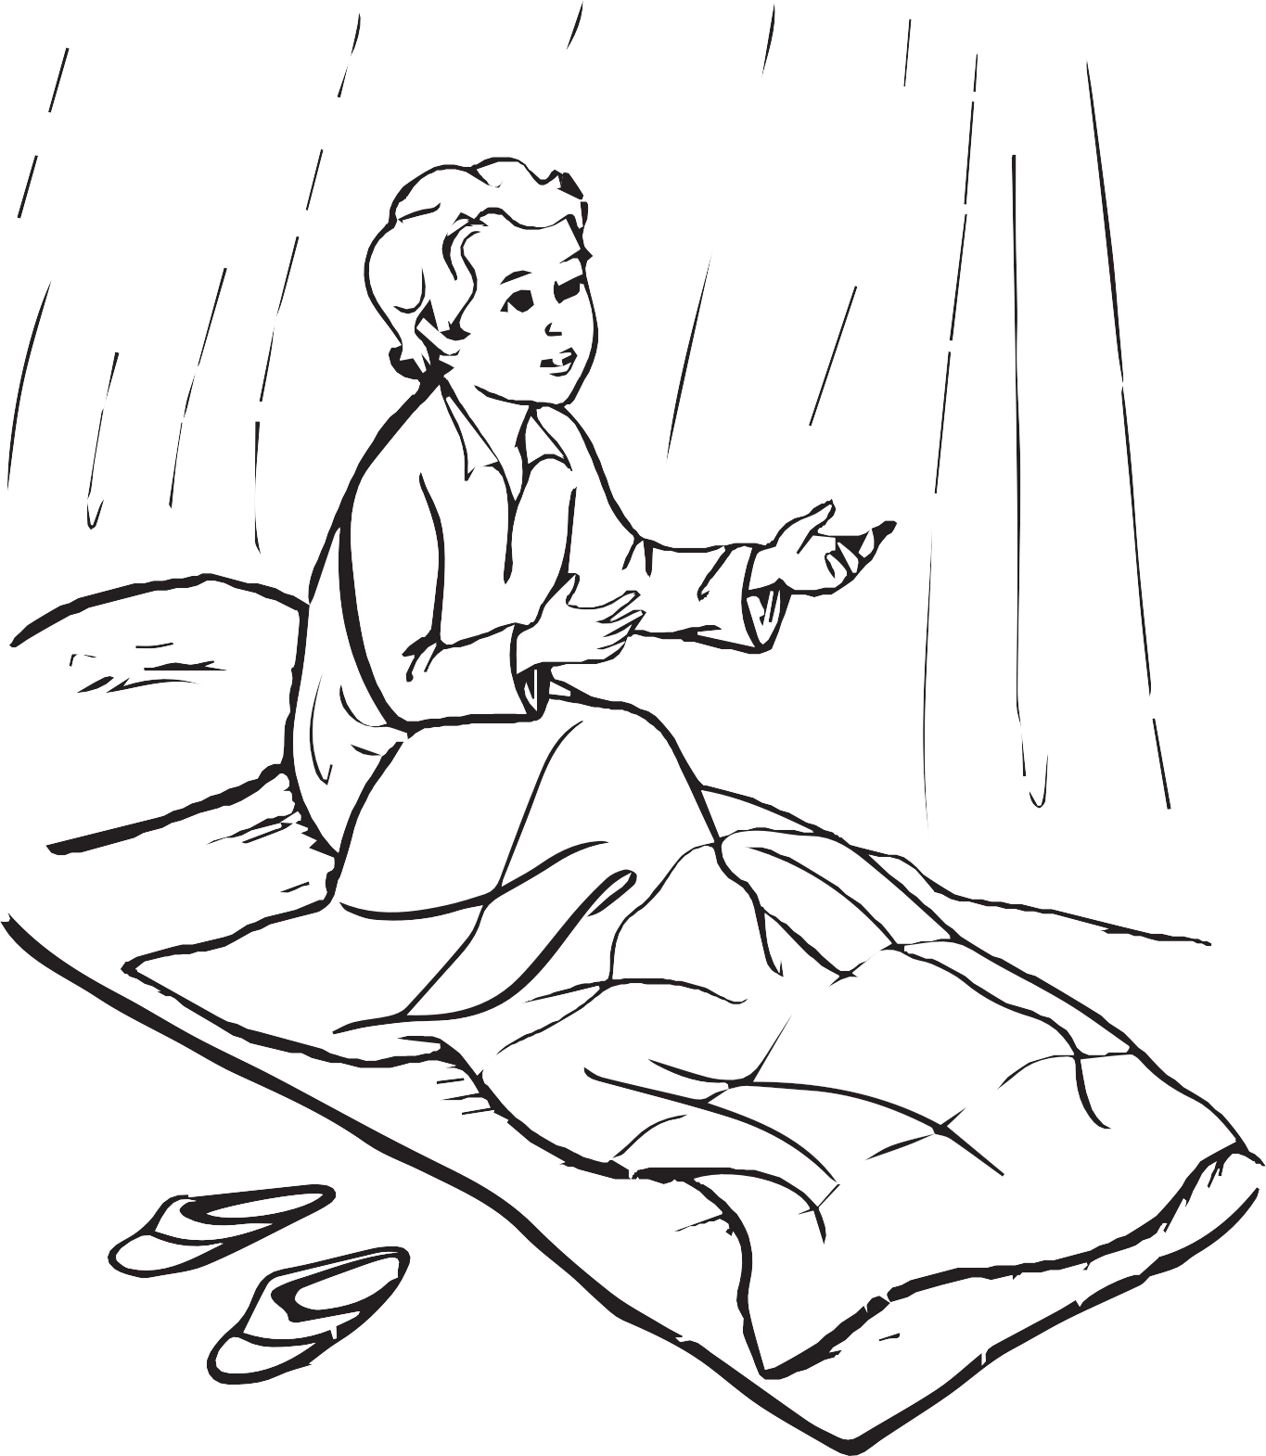

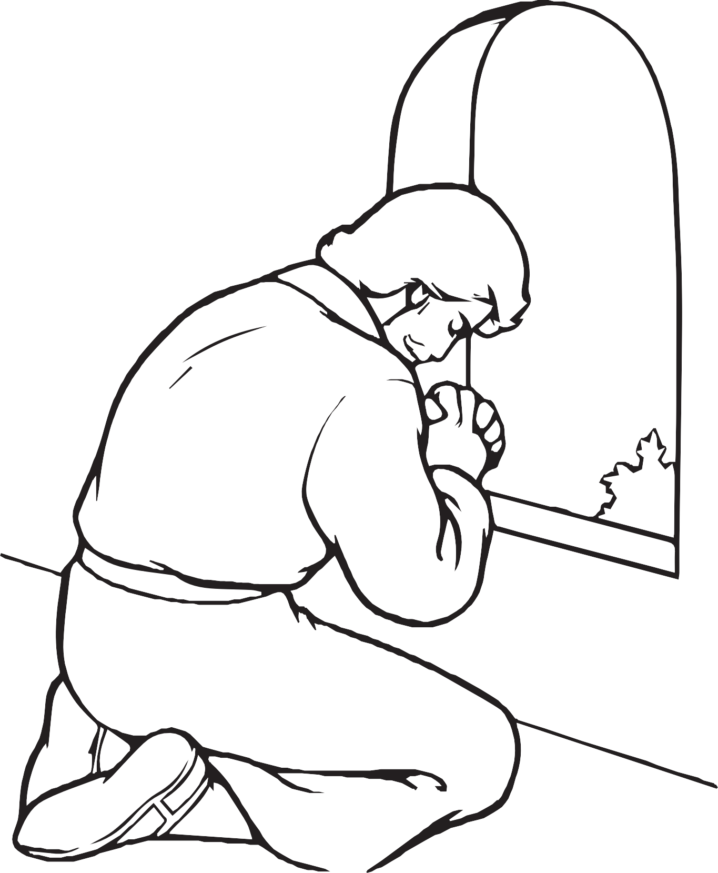

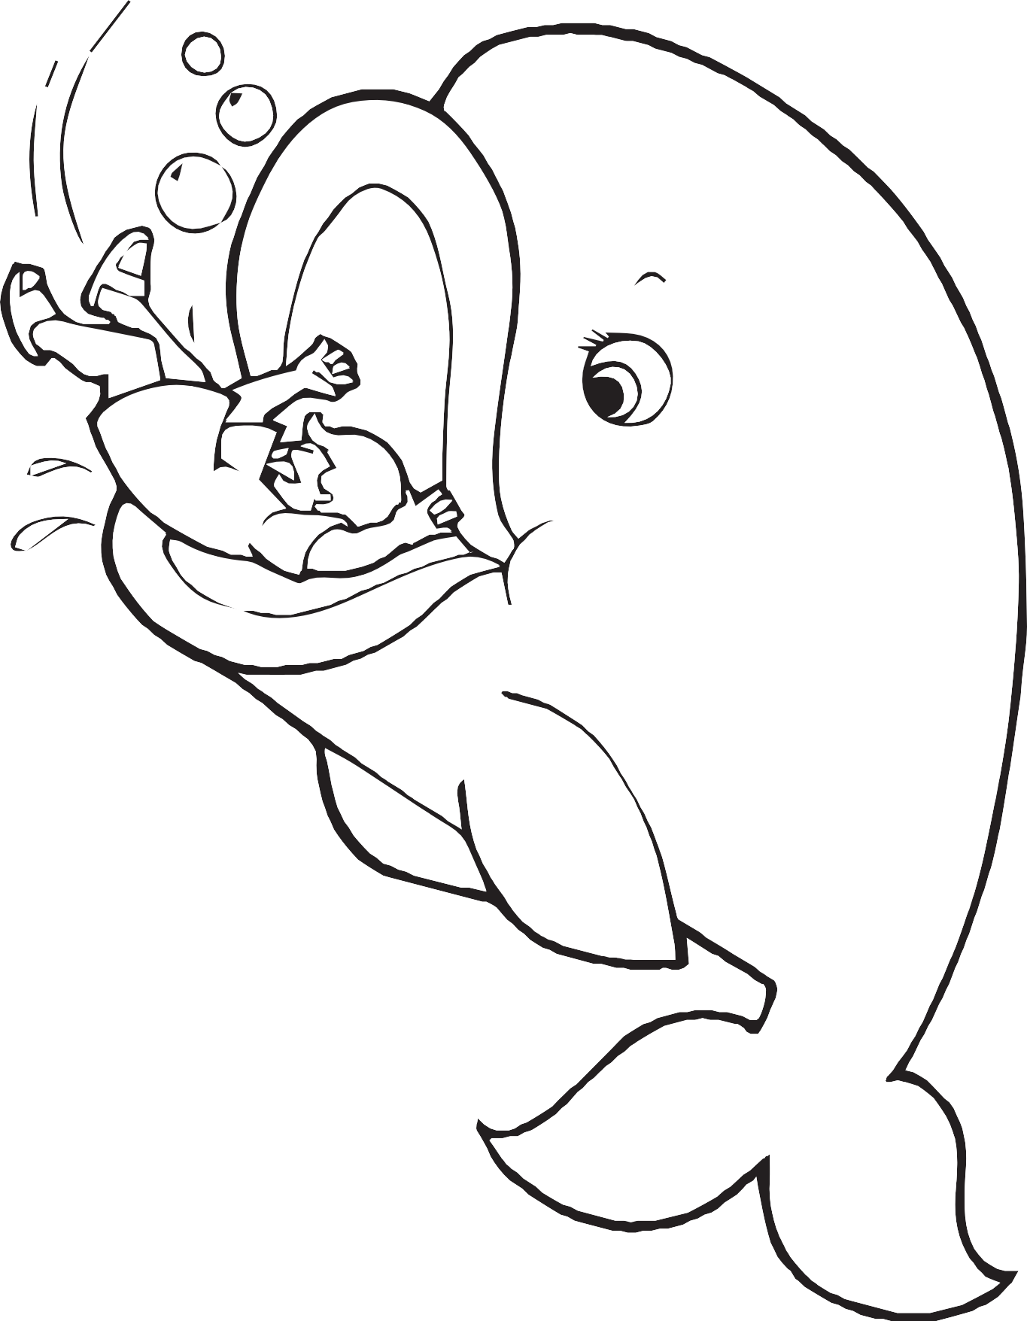

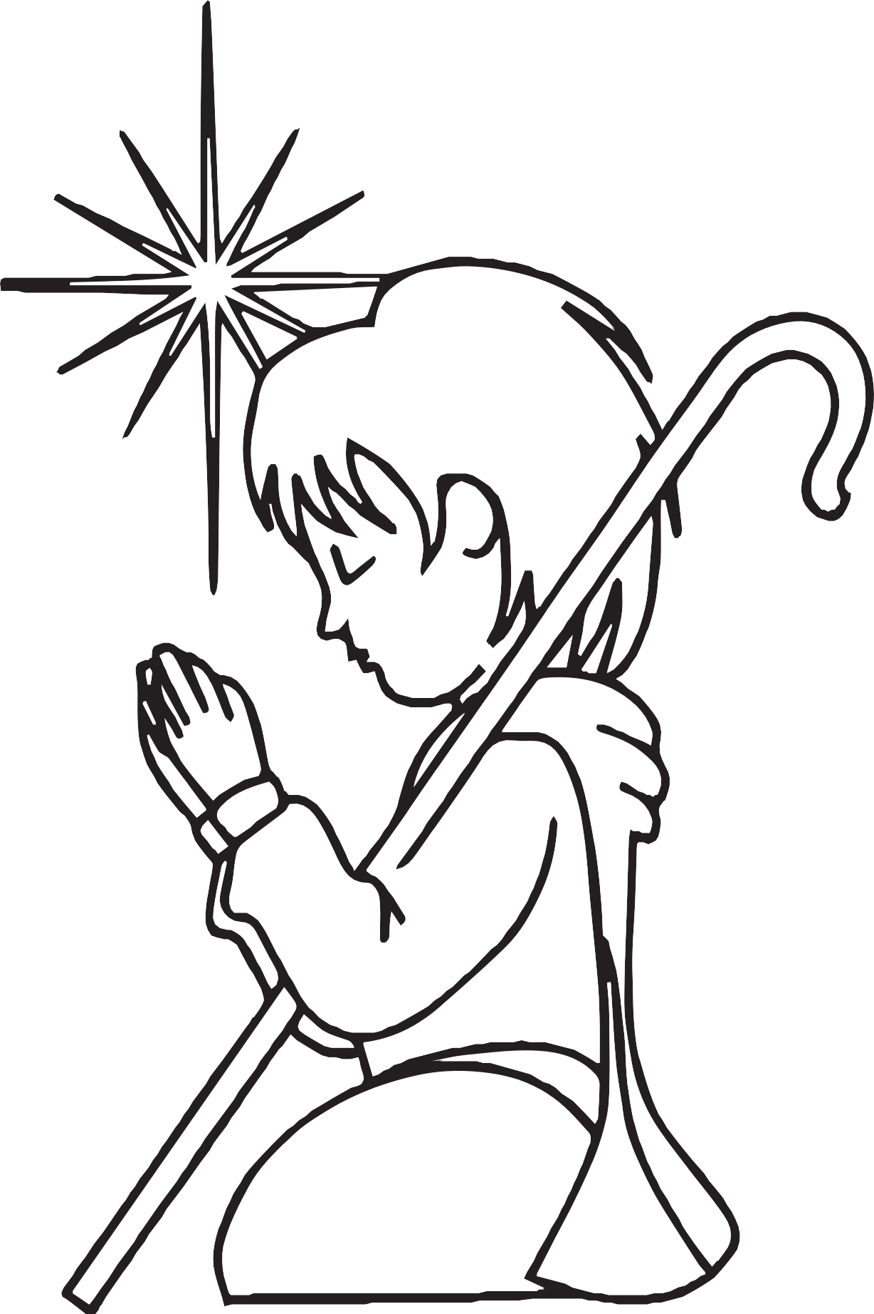

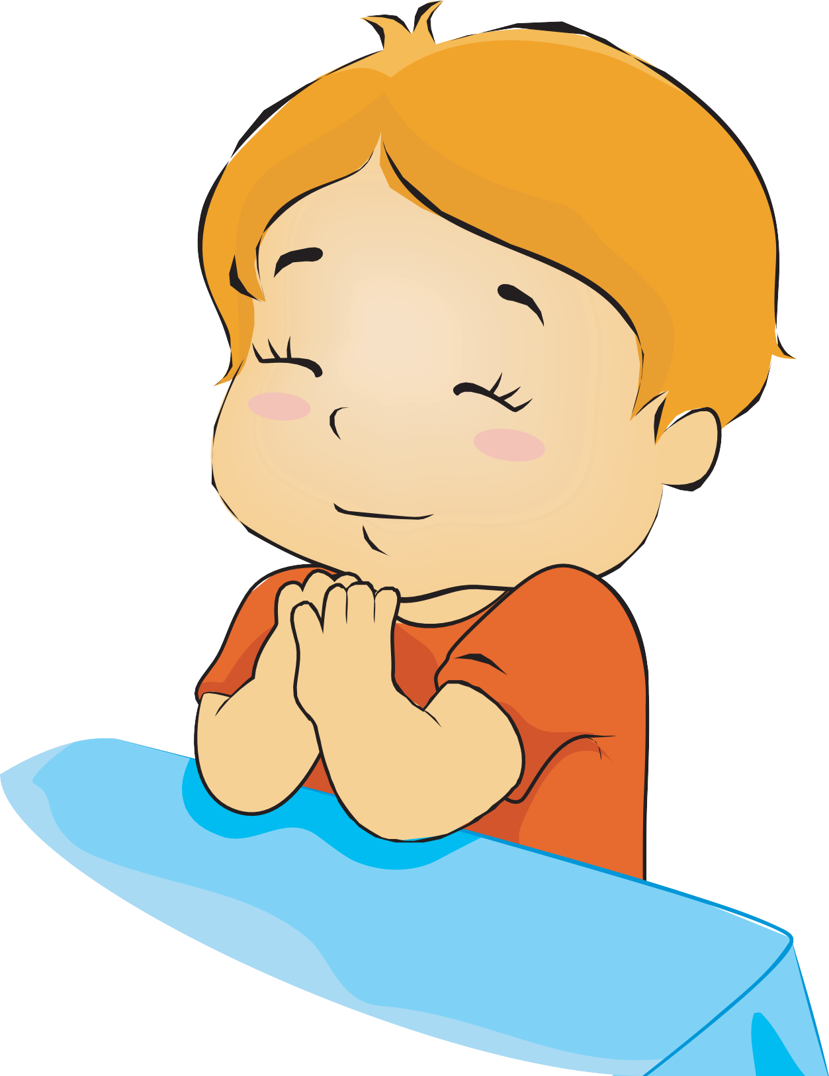

Learn how to pray independently.
b.

Date Completed ____________________________________

Counselor’s Signature _________________________________

Complete the Jesus Star award
c.
- Who created the stars and on what day?
________________________________________________________
________________________________________________________

- How did the wise men know Jesus was born?
_______________________________________________________
______________________________________________________
- Identify which direction Jesus will come from?
_______________________________________________________
______________________________________________________
- Draw, cut out, or colour a star.

- Locate the North Star. Visit a planetarium or view stars at night. Place picture of what you did.

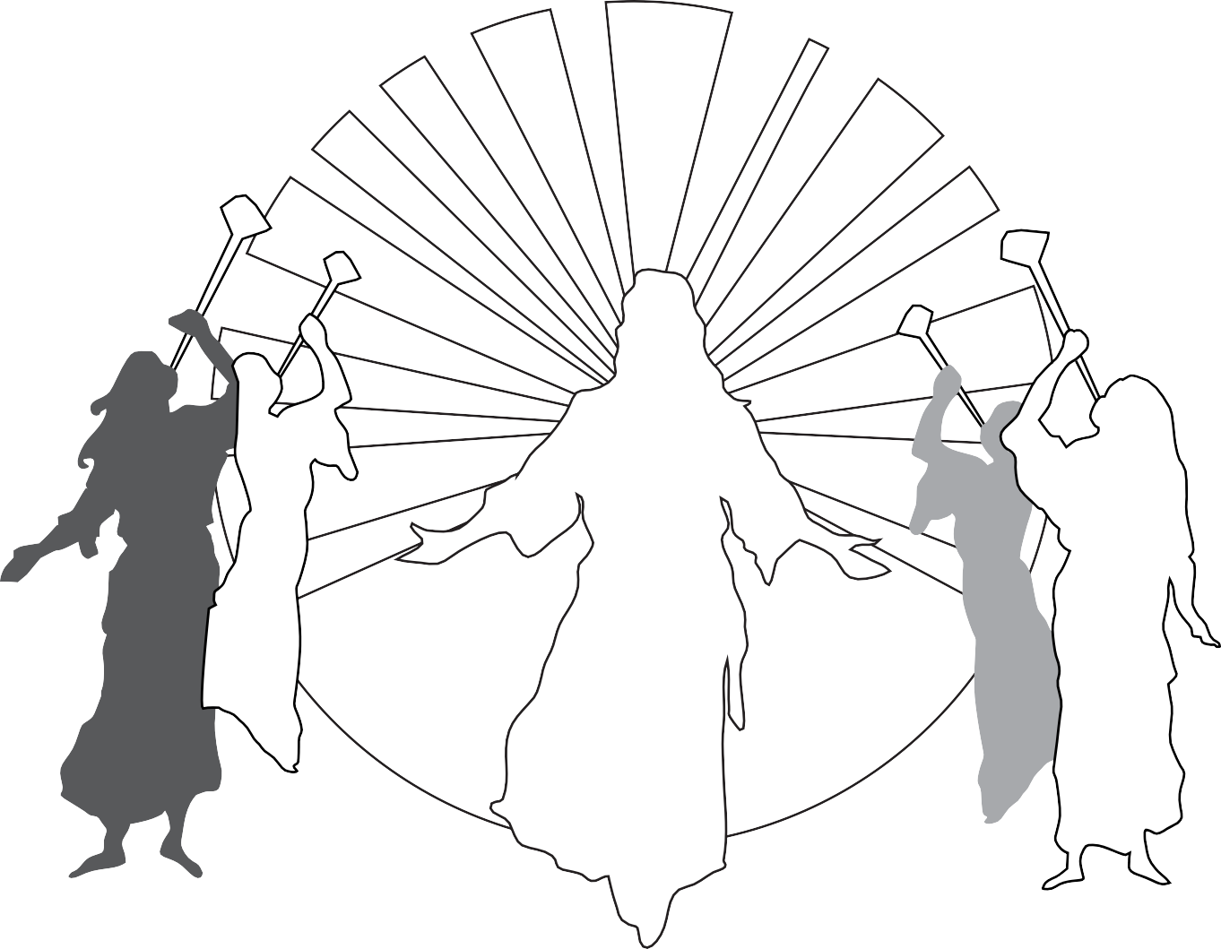

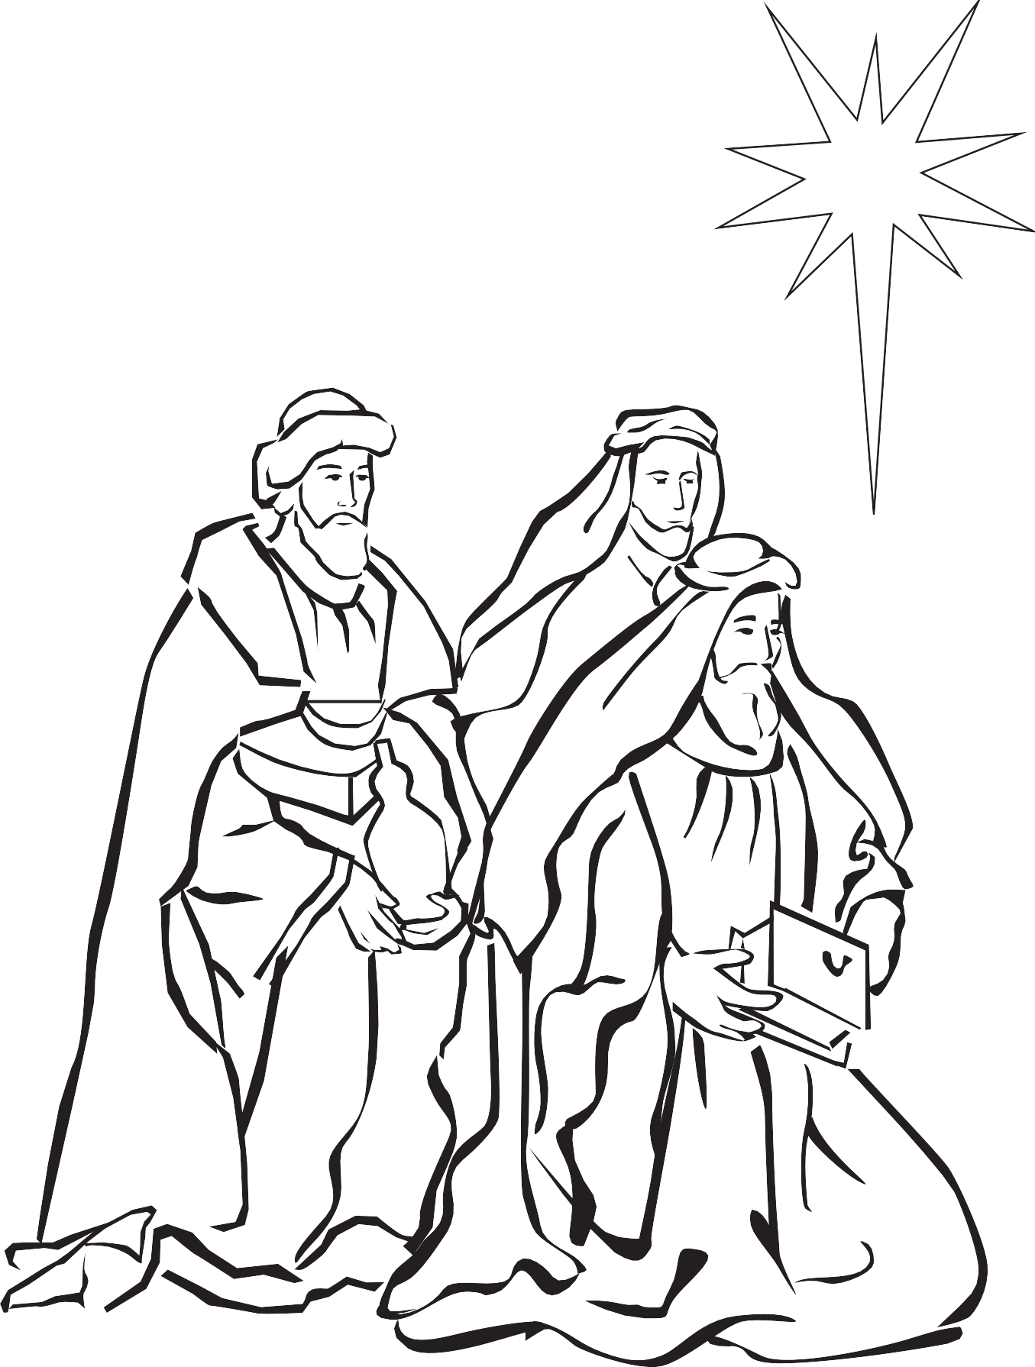

Complete the Bible Friends II award
2
- What does it mean to be a friend?
________________________________________________________________
______________________________________________________________

- Name three Bible Friends.

- Who is your favourite Bible friend? Tell a story about that person.
_________________________________________________________________
_______________________________________________________________
_______________________________________________________________
_______________________________________________________________

- Dress up and act out a story about a Bible friend. Place a picture and put date you did this.

- Tell three things you can do to be a friend for Jesus.

Have a regular family worship time in your home. Keep a record.
3

WEEK ONE
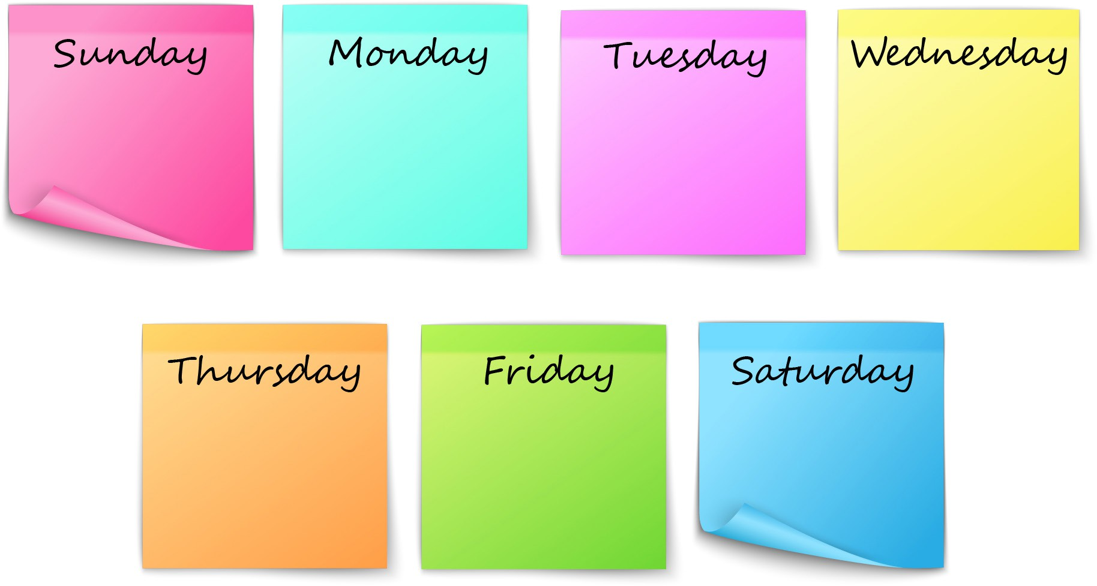
WEEK T WO

Ask someone you know why they pray.
b.

__________________________________________________________

__________________________________________________________

Complete the God’s World award.
- Who made our world? (Learn Genesis 1:1).
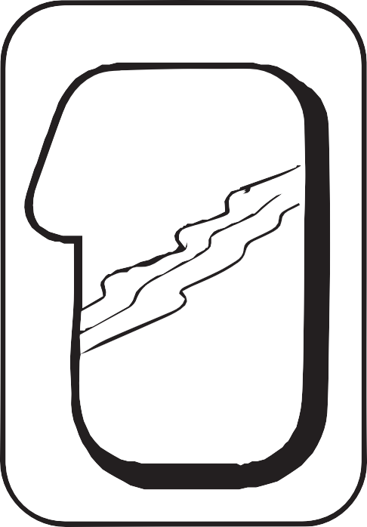

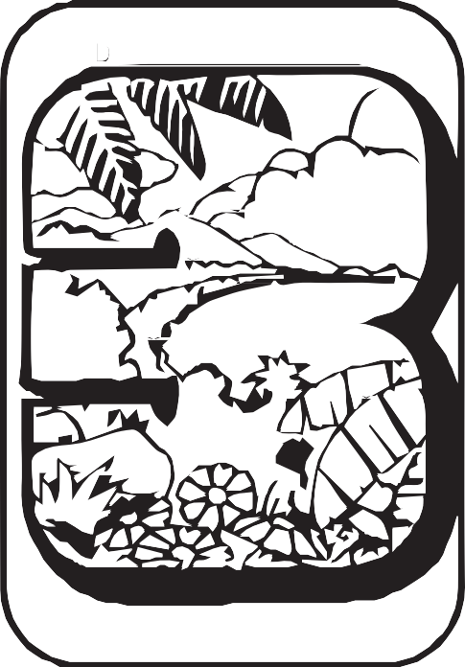
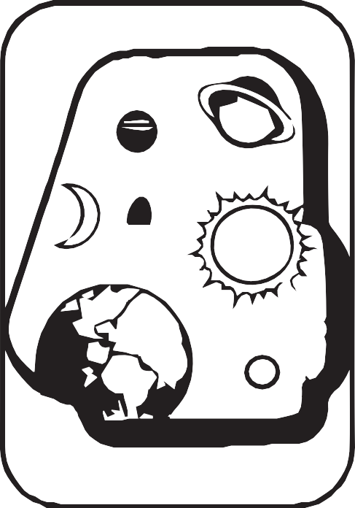

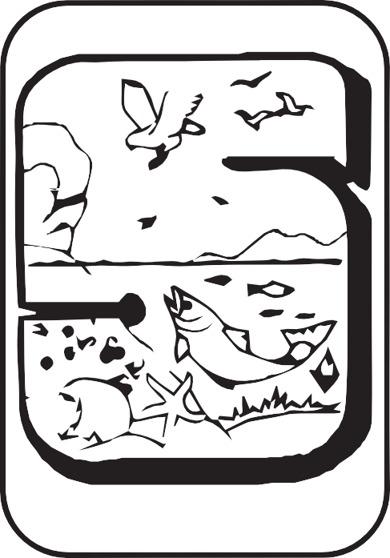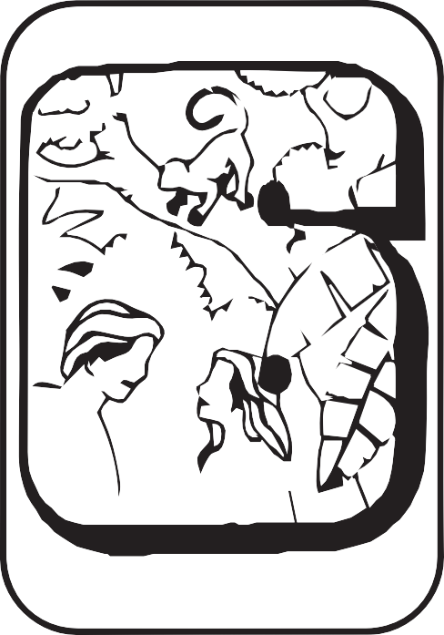

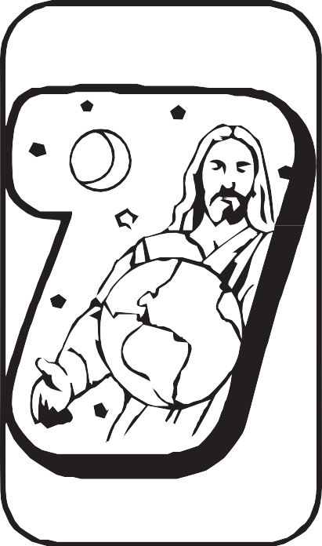

- Act out the story of creation while someone reads or tells it.

Date completed: ________________________________
- Sing a song about your world.
Date Completed: ______________________________
- Look at a globe or map and show and show where you live (next page).
- Name five (5) of your favourite things God created for you. (Note taking area for adult care givers)

- Make a collage, colour a picture of God’s world, or take a walk outside and find things He made. Place a picture for evidence.

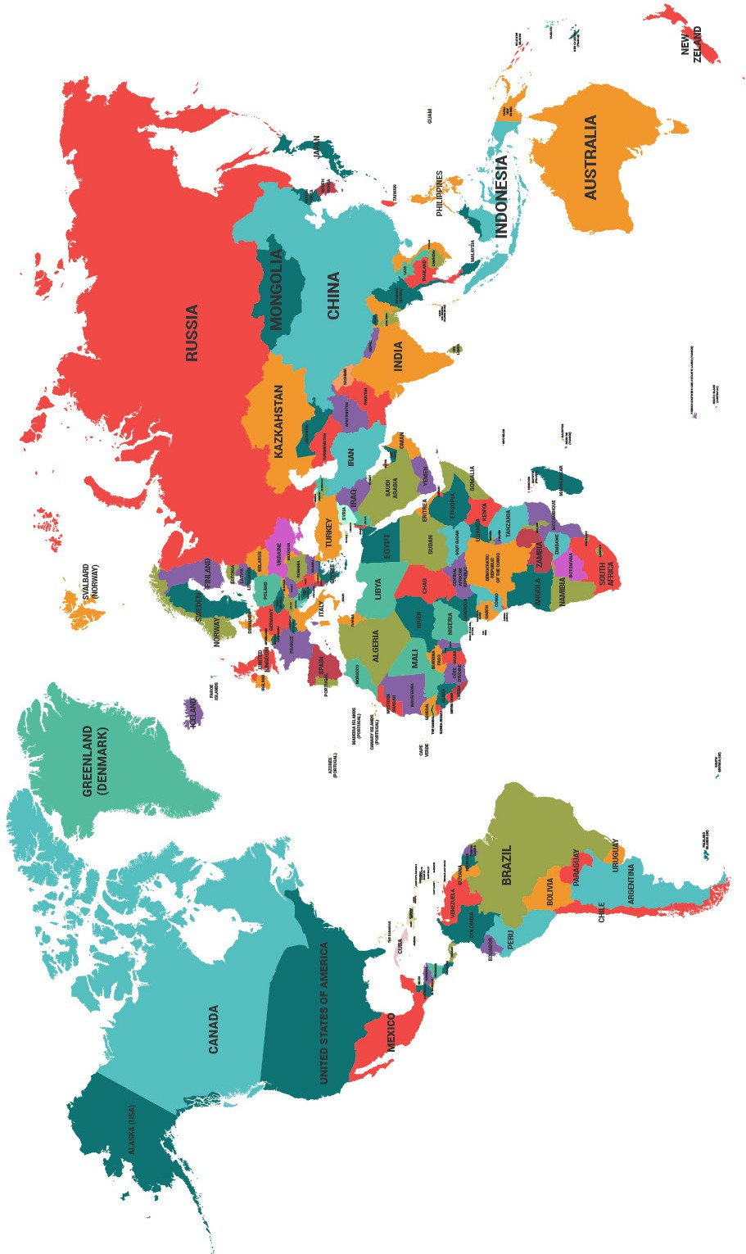

Complete the Left & Right award.
1

- Play “Simon Says” using left/right. Place picture for evidence.

- Which hand do you draw with? Print your name.

- Put red dot stickers on the fingers of your left hand. Put blue dot stickers on your right hand.
Note: Teach this requirement with #4

- Which side of a faucet is the hot water? Which side is cold?
HOT COLD




- Put your shoes on the correct feet.

Date Completed________________________

Counselor’s Signature ___________________________________

- Practice marching while chanting, “Left, Right, Left.”
Place picture of you marching.

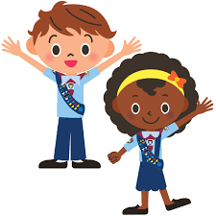

Complete the Manners Fun award.
2

- Learn the Golden Rule (Matthew 7:12).

“Therefore, whatever you want men to do to you, do also to them, for this is the Law and the Prophets.”
Matthew 7:12

- What are five politeness words used in your culture to demonstrate good spoken manners?
_____________________________________________________
____________________________________________________
____________________________________________________
____________________________________________________
____________________________________________________


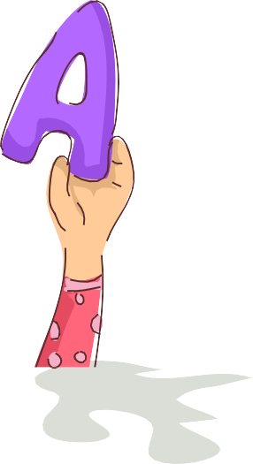
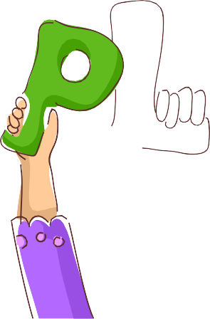
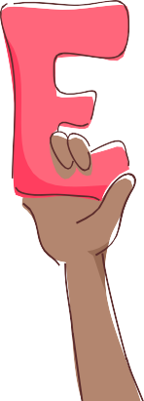
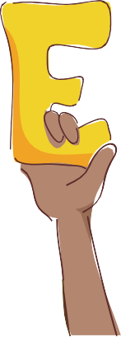
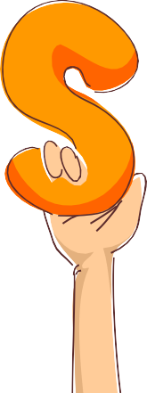

- Draw or cut and paste pictures to illustrate one of these politeness words.

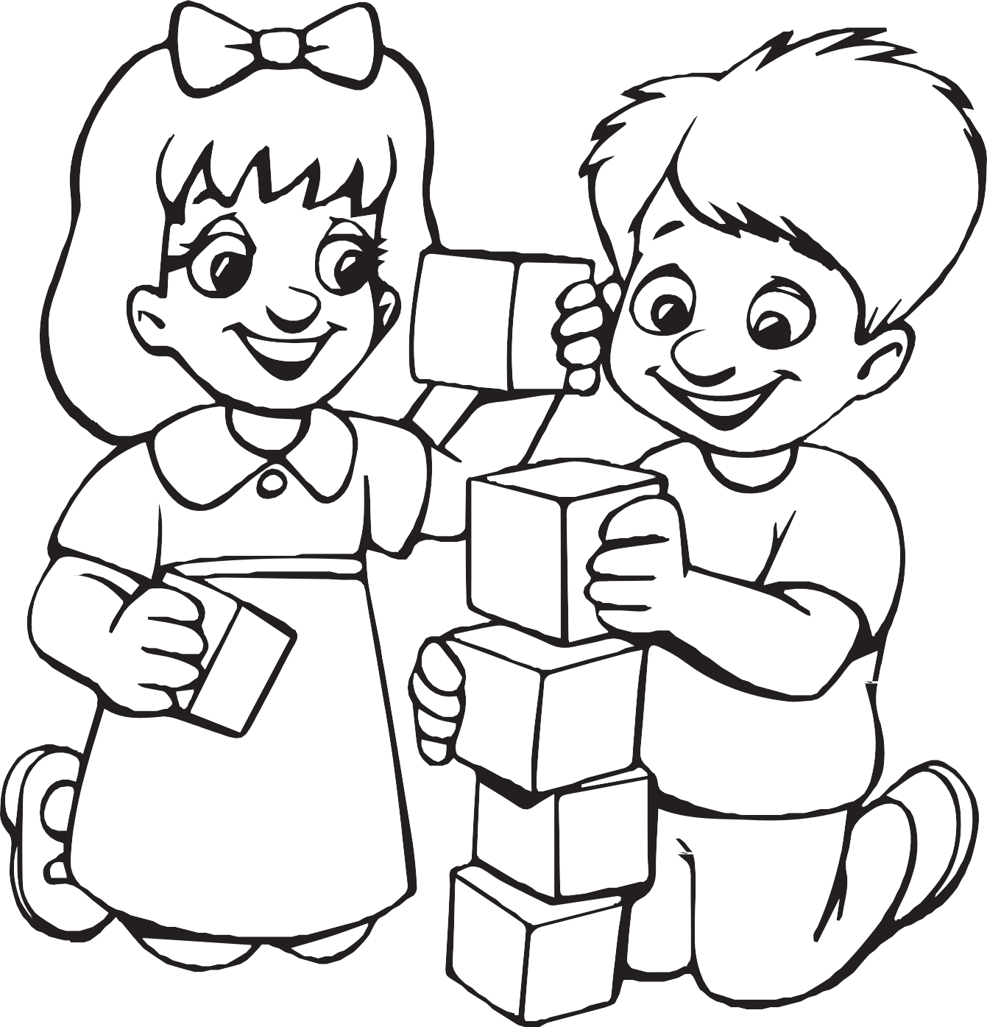

- Play a game using five politeness words.

Politeness  words | 1 | 2 | 3 | 4 | 5 | 6 | 7 | 8 | 9 | 10
PLEASE
THANK YOU
YOU’RE WELCOME
EXCUSE ME
I’M SORRY

Complete the Know Your Body award.
3

- Learn I Corinthians 6:19.

“Or don’t you know that your body is a temple of the Holy Spirit who is in you?
Don’t you know that you have the Holy Spirit from God, and you don’t belong to yourselves?”
I Corinthians 6:19. (CEB)


- Name twelve parts of your body.
___________ _________ _______ _________

___________ ____________ ___________

___________ __________ ___________ ____________ __________

- Draw your body and label the twelve parts. (Place on a separate paper)

- What are knees for?
_________________________________________________

_________________________________________________

- What does your face do for you and others?
_________________________________________________

__________________________________________________

- Name some useful things you can do with your hands.

__________________________________________

__________________________________________

__________________________________________
- How can you use your mouth for Jesus?
____________________________________________
__________________________________________



Cue Cards

Say the fifth commandment: “Honour your father and your mother” (Exodus
20:12).
1

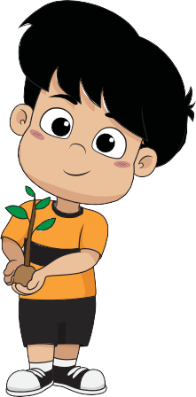

Complete the Helping at Home award.
2

- What body parts do you use to help at home?

___________________ _____________________ __________________

_____________________ __________________ _____________________

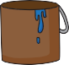
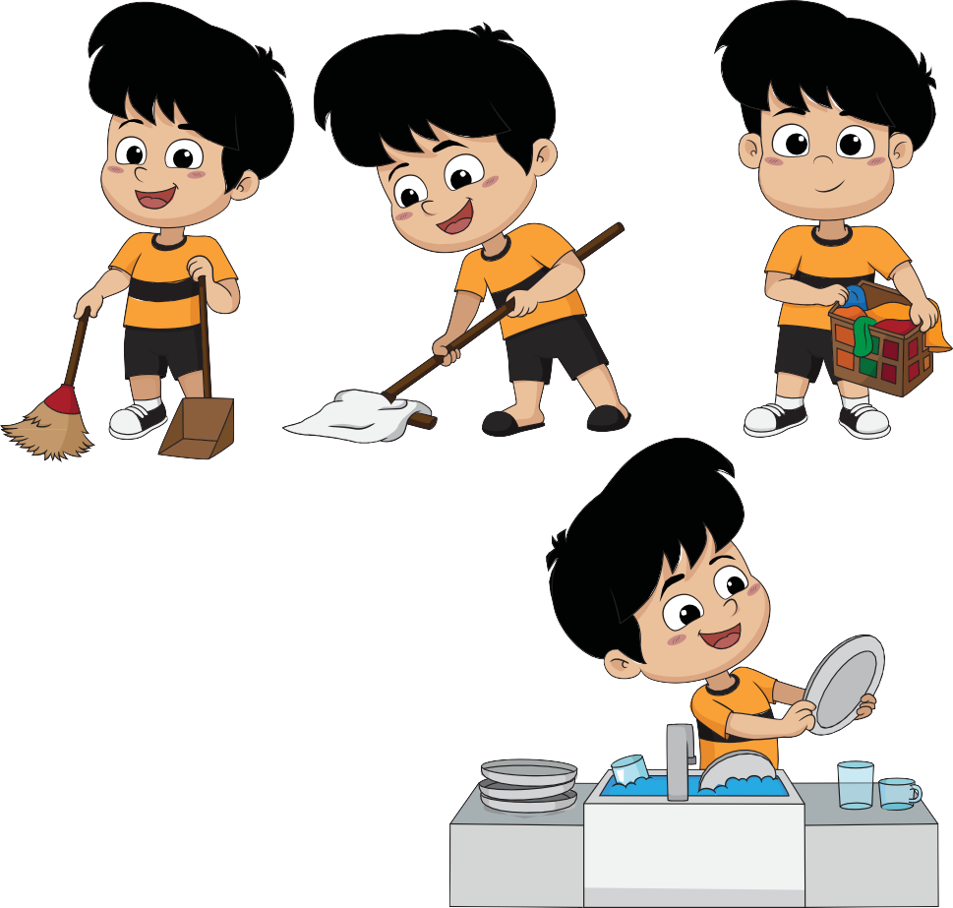
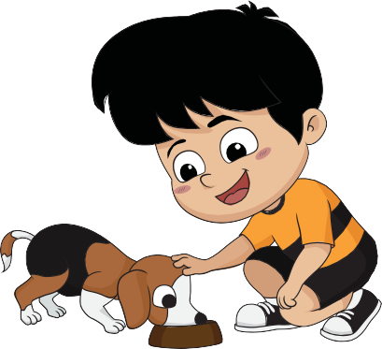
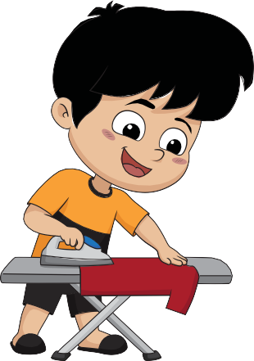
- Circle which of the following you think you could do to help at home or draw your own.

- From question #2, pick one of the ways to help at home and help for one week.

Way to help
Day #1
Day #2
Day #3
Day #4
Day #5
Day #6
Day #7

- Learn a song about helpers.






- Have someone read you the story from a Bible or storybook.

Date Completed ____________

Counselor’s Signature _______________

Complete the Fire Safety award.
3

- What should you do if your clothes catch on fire?

_________________________________________________________

_______________________________________________________

_______________________________________________________

- What should you do if there is smoke in your house and it’s hard to breathe?

________________________________________________________

_______________________________________________________

_______________________________________________________

- Memorise your phone number and street address.
  - PHONE NUMBER:
  - ADDRESS:

- What phone number do you call if there is a fire? What do you tell the person who an- swers the phone?
  - PHONE NUMBER:

- Either visit a fire department or have a fireman or fire truck and team visit your group.

What you did _______________________________________

Date Completed _____________________________________

Counselor’s Signature _________________________________















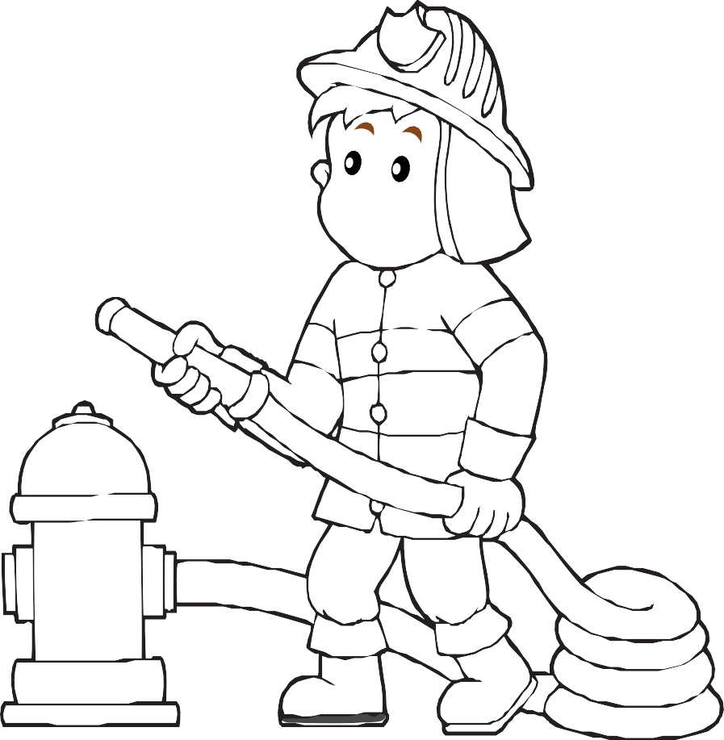





Complete the My Community Friends award.
1

- Name five (5) different friends who live in your community. (Note taking area for adult care givers)

- Make a scrapbook or collage of your neighbourhood friends, including at least five (5) different people (on the next 5 pages).

- Tell three (3) things that you and your friends can do to make your neighbourhood a better place. (Note taking area for adult care givers)

# 1 - My Friend

# 2 - My Friend

# 3 - My Friend

# 4 - My Friend

# 5 - My Friend

- Tell one of your friends that Jesus loves them.

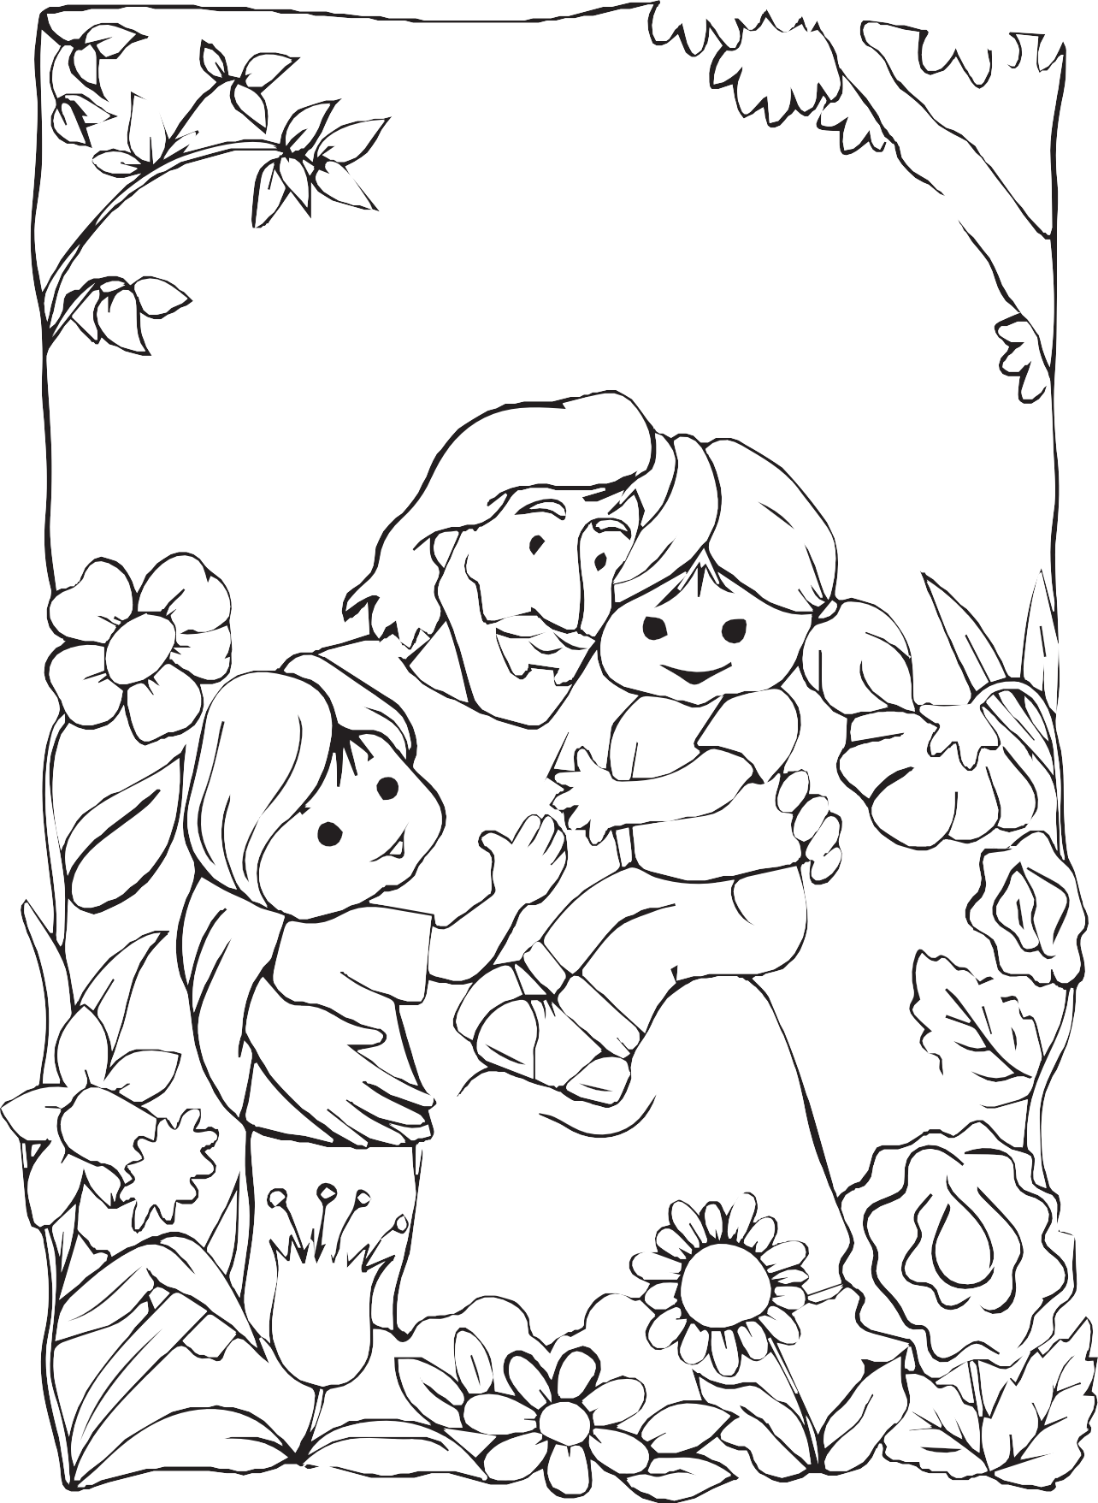

- Do something nice for a community friend.

What to Do Which Community Friend




- Make a new friend in your neighbourhood.


Complete the Playing with Friends award.
2

- What is a friend?
____________________________________________

____________________________________

- Name three ways you can make friends. (Note taking area for adult care givers)

- Name four things you can talk about to be friendly with someone. (Note taking area for adult care givers)

- Name four things you need to think about when choosing a friend. (Note taking area for adult care givers)

- Name three ways that you can know a person is a right friend for you. (Note taking area for adult care givers)

- Did Jesus have friends? Have an adult help you find a story in the Bible about some of His friends. (Note taking area for adult care givers)






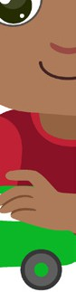


- Make a craft to give to your friend.












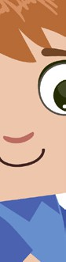


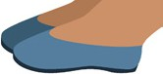










- Do your choice of one of the following: Learn a song about friends.






Make a scrapbook about a new friend.
Learn or experience a poem about a friend. Tell a story about a friend.

Complete the Scavenger Hunt award.
3

- Go on a scavenger hunt with one of your parents, a teacher, or another adult.
Date Completed ___________________
Counselor’s Signature _________________________
- Find two items in nature (rock, pebble, feather, nuts, leaves, etc.).
- Find something relating to a Bible story (small basket = Moses, cotton, lamb’s wool, stones = altar, multi-colored material Joseph’s coat, etc.). Talk about the story.
- Find something that is red (flower, piece of material, colour crayon, etc.).
- Find a plastic egg (or another type of container), open it and share with another Early Bird. (Can put grapes, raisins, candy, or whatever you like.)
Scavenger Hunt award checklist
Requirement 2: Find two items in nature
rock/pebble
feather
nuts
yellow leaf
a tiny wildflower
a stick shaped like a letter
brown leaf
Requirement 3: Find something relating to a Bible story
small basket = Moses, cotton, lamb’s wool
stones = altar, multi-coloured material Joseph’s coat
Requirement 4: Find something that is red
flower
piece of material
colour crayon
Requirement 5: Find a plastic egg (or another type of container)
plastic egg
another container

Additional awards which Early Birds could earn.
1

- Alphabet Fun
- Animal Homes
- Animals*
- Beginning Biking
- Beginning Swimming
- Crayons and Markers*
- Gadgets and Sand
- Jigsaw Puzzle*
- Pets
- Shapes & Sizes*
- Sponge Art*
- Stamping Fun
- Toys*

* = Suggested award in annual plan, though not required for Early Bird pin.


























































