




Activity Book

This book belongs to
General Conference Youth Ministries Department

Builder
Activity Book

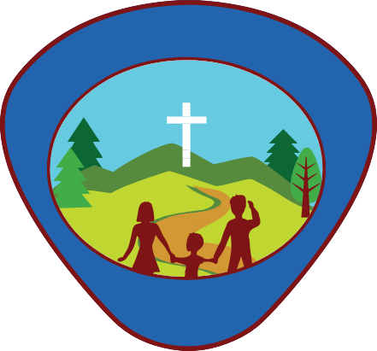
General Conference Youth Ministries Department
L
T
C
U
R
E
R
A
D
V
E
B
U
N

Produced by:
General Conference Youth Ministries Department 12501 Old Columbia Pike
Silver Spring, MD 20904

Departmental Director: Gary Blanchard Associate Youth Director: Pako Mokgwane Associate Youth Director: Andrés J. Peralta Editor-in-Chief: Andrés J. Peralta Departmental Advisor: Abner De Los Santos Senior Editorial Assistant: Kenia Reyes-de León

Project Manager: Mark O’Ffill
Content Contributors: Mark O’Ffill
Ted & Betsy Burgdorff

Copy Editor: Mark O’Ffill

Cover & Interior Designer:
Jonatan Tejel Isaac Chia
Adrian Gutierrez Perez Wilbert Hilario (ClicArt) Had Graphic Inc. hadgraphic@gmail.com
Photos by: © Shutterstock Resources:
Gomez, Ada. “Adventist Adventurer Awards.” Adventist Ad- venturer Awards - Wikibooks.org. North American Division Club Ministries, 2014. Web. 26 July 2017. <https://en.wiki- books.org/wiki/Adventist_Adventurer_Awards>.

Gooch, Jennifer A. Eager Beaver Leader’s Guide with 23 Themed Meeting Plans. 3rd ed. Lincoln, Neb.: Advent- Source, 2007, 2015. Print.

For information
Email: youth@gc.adventist.org Website:
youth.adventist.org

Builder Checklist

Name: Date Started: Date Completed:

Basic Requirements
- Repeat from memory the Adventurer Pledge and Law
- Explain the Pledge and Law through art or skit
- Complete the Reading III award
- Complete the Building Blocks award
My God
- God’s Plan to Save Me
  - a. Create a story chart showing the order in which these stories took place: Noah, Abraham, Moses, Ruth,
David, Daniel, Esther
  - Make a diorama, poem, or song about one of the stories above to show someone how to live for God
- God’s Message to Me
  - Complete the Bible lll (red) (formerly titled Bible ll) award
- God’s Power in My Life
  - Spend regular quiet time with Jesus to talk with Him and learn about Him. Keep a record
  - Ask three people who their favourite Bible hero is (other than Jesus) and why
  - Complete the Prayer award
My Self
- I Am Special
  - Put together a scrapbook, poster, or collage, showing some things you can do to serve God and others
- I Can Make Wise Choices
- I Can Care for My Body
  - Complete the Temperance award
My Family
- I Have a Family
  - Share one way your family has changed over time. Share how these changes make you feel
  - Find a story in the Bible about a family like yours
- Families Care for Each Other
  - Learn how to play a game through which each of your family members show appreciation to each of the other members of the family
  - Complete the Family Helper award
- My Family Helps Me Care for Myself
  - Complete the First Aid Helper award
My World
- The World of Friends
  - Complete the Caring Friend award
- The World of Other People
  - Know and explain your national anthem and flag
  - Name your country’s capital, and the leader of your country
- The World of Nature
  - Complete a nature award not previously earned, such as:
    - Bodies of Water
    - Insects
    - Stars
    - Weather or
    - Zoo Animals
Instructor Checklist
Basic Requirements

My God

a.
b.

a.

a.
b.
c.
My Self
1.
a.
b.
2.
a.

3.
a.

My Family
1.
a.

2.
a.

b.

3.
a.

My World
1.
a.

2.
a.

b.

- Complete the Media Critic award 3.
- Complete the Wise Steward award a.

Explain the Pledge and Law through art or skit.
2

“Because Jesus loved me, I will always do my best.”
Adventurer Pledge


Jesus can help me to:

- Be obedient
- Be pure
- Be true
- Be kind
- Be respectful
- Be attentive
- Be helpful
- Be cheerful
- Be thoughtful
- Be reverent

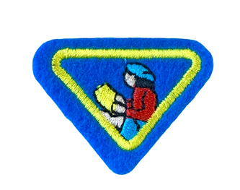
Awarded to Adventurers who read, or listen while someone else reads: (tick on the circles when you finish each one and record on the reading log)
  - Three chapters from the book of Acts from a modern translation of the Bible.
  - A Bible story or book about Jesus.
  - A book on health or safety.
  - A book on family, friends, or feelings.
  - A book on history or missions.
  - A book on nature.

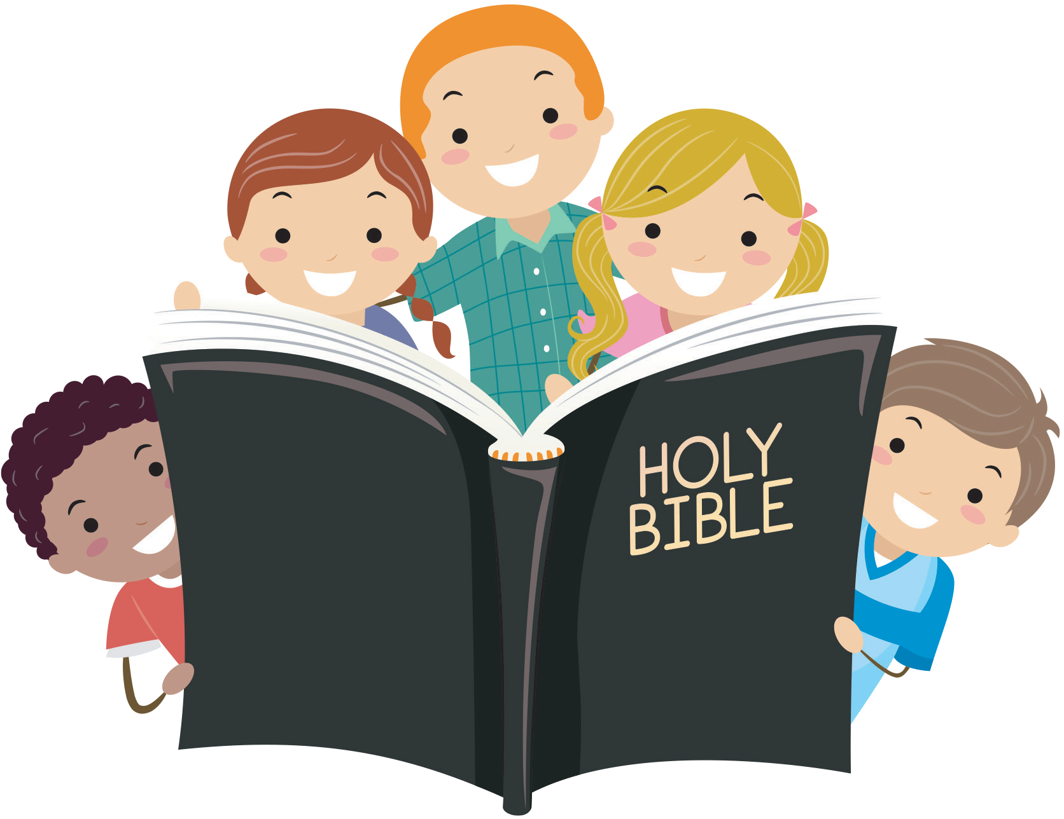


Reading Log

Name: Month:

Name of book | Author | Date completed | Comments

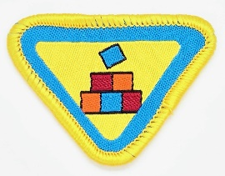

Complete the Building Blocks Award
4

  - Find in the Bible and review three (3) or more of the stories listed below:
(Tick your 3 choices)
    - Noah (Gen 6-7);
    - Tower of Babel (Gen 11:1-9);
    - Abram’s tent (Gen 12:1-8);
    - Wilderness tabernacle (Ex 25-27);
    - Solomon’s temple (1 Chronicles 28:1-10, 2 Chronicles 3-5);
    - Manger (Luke 2:1-20);
    - Wise man and foolish man (Luke 6:47-49);
    - New Jerusalem (Rev. 21-22).

(Record your review of what you read below)
Review 1. ______________________________________________________
______________________________________________________________
______________________________________________________________
Review 2. ______________________________________________________
______________________________________________________________
______________________________________________________________
Review 3. _______________________________________________________
______________________________________________________________
______________________________________________________________

  - After reading the Bible stories in requirement 1, list some things that were the same and things that were different about all the building projects (materials, location, size, purpose). Why was each building project built?
Story 1:
Story 2:
Story 3:

  - Invite a builder or carpenter to talk about the:
    - tools he uses (display and demonstrate - record below)


    - kinds of things he builds (Record below)


    - list the safety rules he follows ____________________________________
__________________________________________________________
__________________________________________________________
__________________________________________________________

    - list values like being honest, measuring carefully, following instructions/plans, setting a strong foundation __________________________________________
___________________________________________________________
___________________________________________________________
___________________________________________________________

  - Share 2 choices that you can make this week that will build up and not break down your character.
Choice 1: ____________________________________________________
____________________________________________________________
Choice 2: ____________________________________________________
____________________________________________________________

  - Discuss how a building and its foundation are a lot like our lives and our choices. Read & discuss 1 Corinthians 3:11 and Philippians 4:8 as part of your answer.
1 Corinthians 3:11 ________________________________________________
_______________________________________________________________
_______________________________________________________________
Philippians 4:8 ____________________________________________________
_______________________________________________________________
_______________________________________________________________

  - Read Revelations 21-22
    - Learn about the heavenly home that God is making for all who choose His gift of eternal life. __________________________________________________
__________________________________________________________
__________________________________________________________

    - What building materials is He using?


    - Why should we wish to be in heaven?

  - Construct one or more buildings of any size or type. You may work individually or in teams.




















1
Create a story chart showing the order in which these stories took place: Noah, Abraham, Moses, Ruth, David, Daniel & Esther.

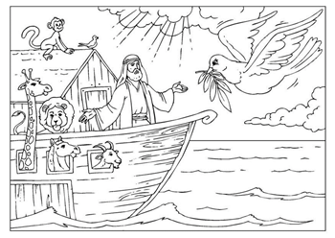
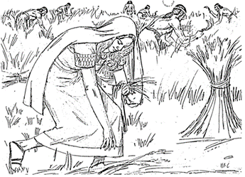

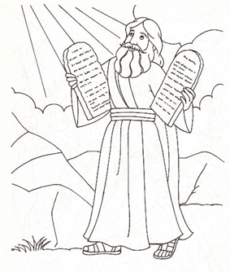
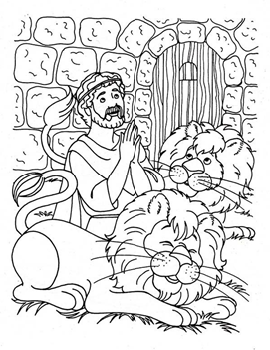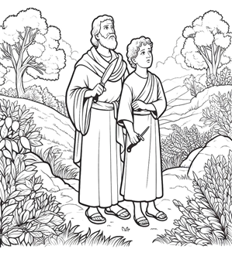
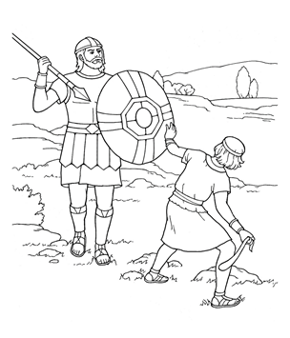
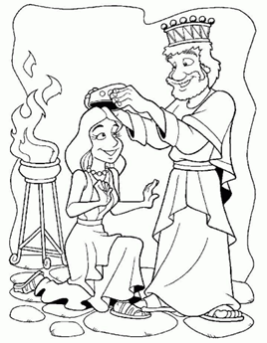

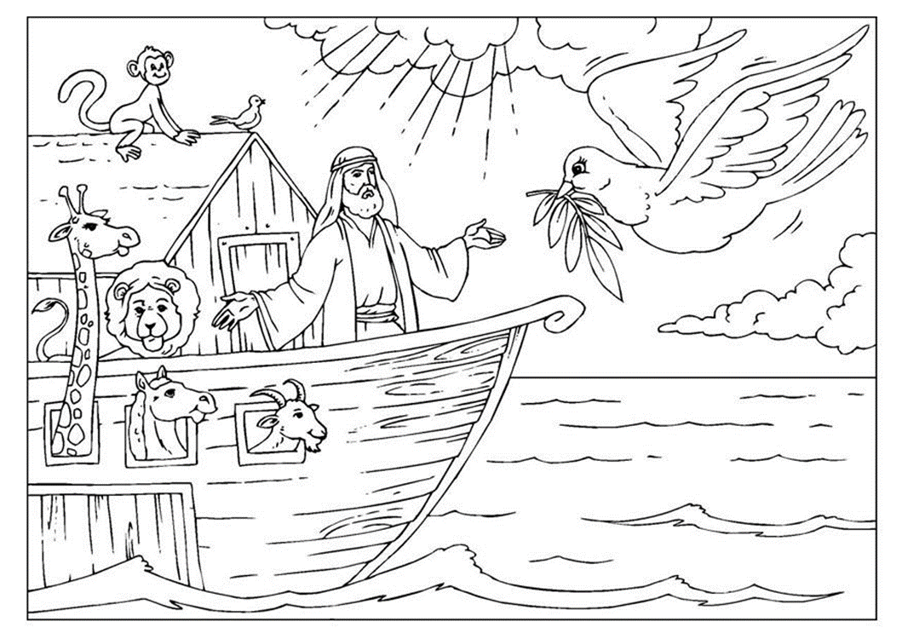

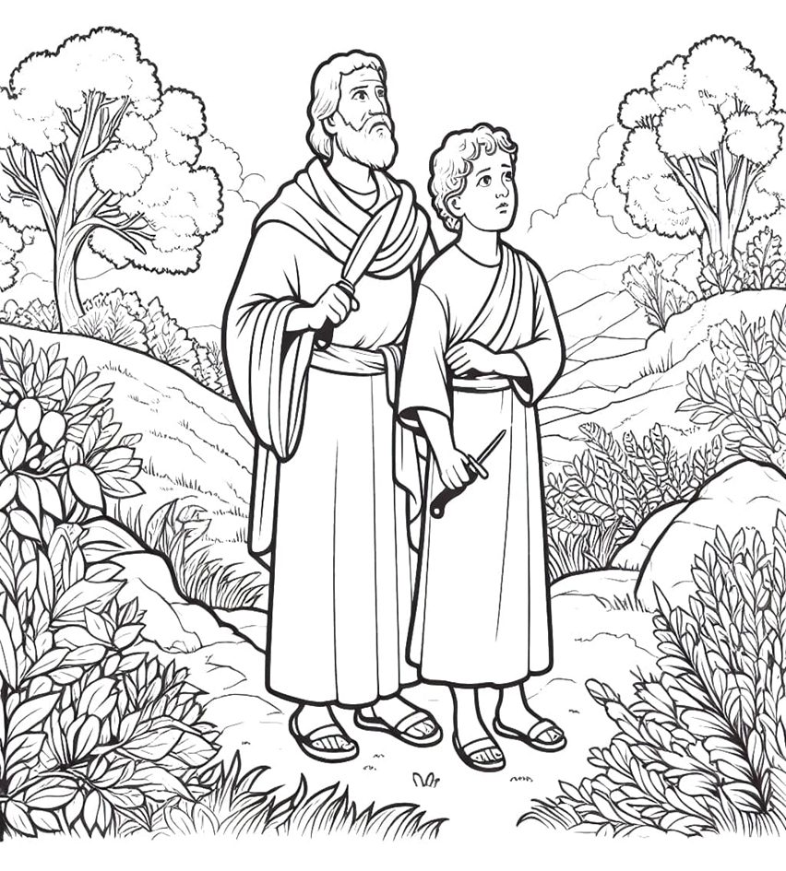
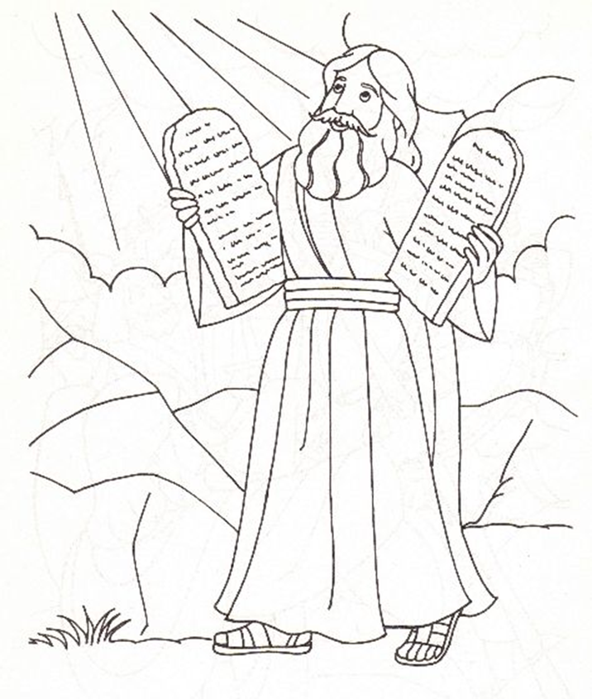

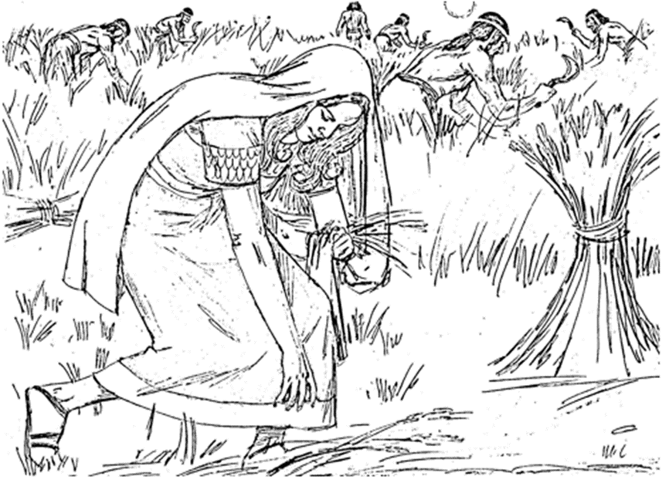

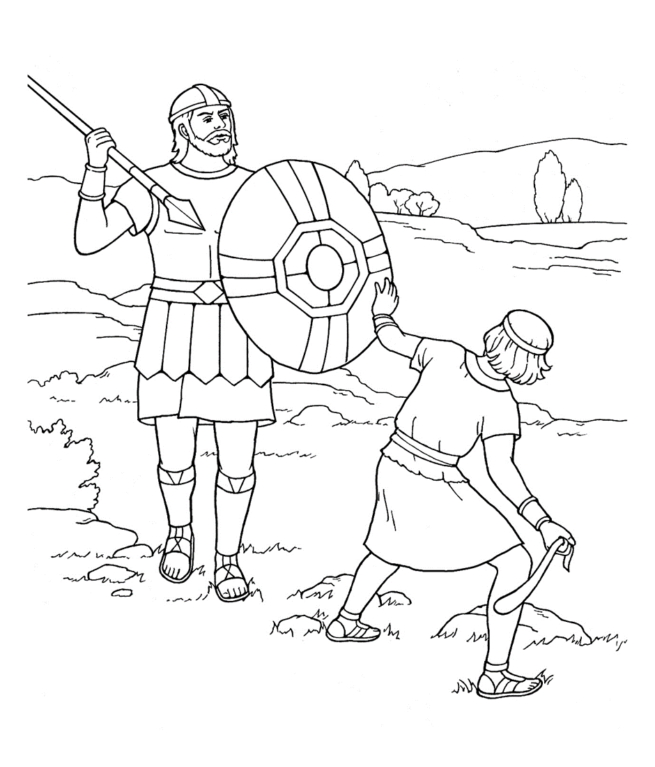

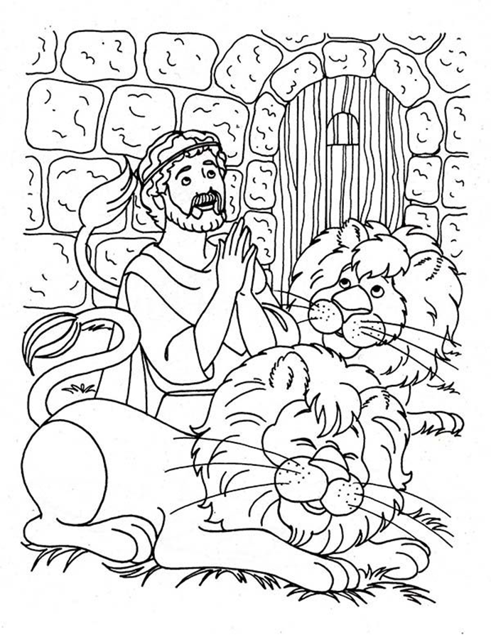

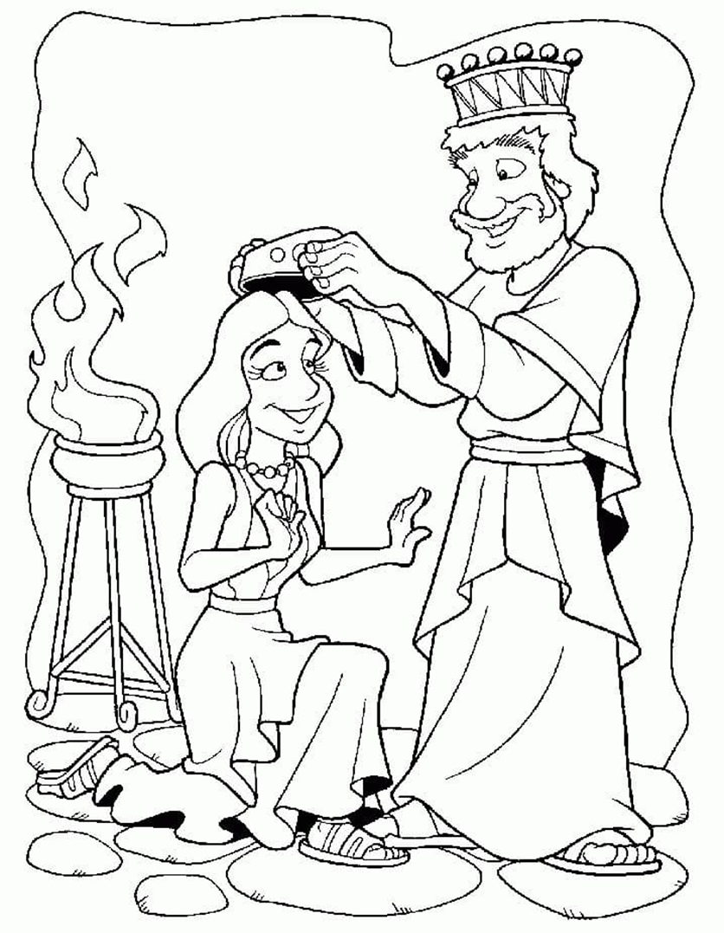

Make a diorama, poem, or song about one of the stories above to show someone how to live for God. (Tick which one you did and write it in the box)

Story
Project

Noah
Abraham Moses Ruth
David Daniel Esther
Diorama Poem Song


- Earn the Bible II award.
- Recite in order the books of the Old Testament.


The Old Testament

Genesis 2 Chronicles Daniel
Exodus Ezra Hosea
Leviticus Nehemiah Joel
Numbers Esther Amos
Deuteronomy Job Obadiah
Joshua Psalms Jonah
Judges Proverbs Micah
Ruth Ecclesiastes Nahum
1 Samuel Song of Solomon Habakkuk
2 Samuel Isaiah Zephaniah
1 Kings Jeremiah Haggai
2 Kings Lamentations Zechariah
1 Chronicles Ezekiel Malachi

- Tell or act out the following Bible stories: (Write what you learnt below)
  - Noah ______________________________________________________
___________________________________________________________
_________________________________________________________
  - Abraham ___________________________________________________
__________________________________________________________
_________________________________________________________
  - Moses _____________________________________________________
__________________________________________________________
_________________________________________________________
  - David ______________________________________________________
___________________________________________________________
__________________________________________________________
  - Daniel ______________________________________________________
___________________________________________________________
__________________________________________________________
- Read or listen to a Bible story. (Write what you learnt below)

- Memories and explain three of the following verses about living for Jesus. Explain below.
  - Exodus 20:11-17
  - Philippians 4:13
  - Philippians 2:13
  - 1 John 2:1, 2


- Play two games to help you remember the Bible stories. (Write what you did below)


Sat
Fri
Thu
Wed
Tue
Mon
Sun

Spend regular quiet time with Jesus to talk with Him and learn about Him.
Keep a record.
3
FAMILY worship TIME RECORD
Week 1 | Week 2 | Week 3 | Week 4

Ask three people who their favourite Bible hero is (other than Jesus) and why.
b.


Name:
Bible Hero:
Why:

Name:
Bible Hero:
Why:

Name:
Bible Hero:
Why:

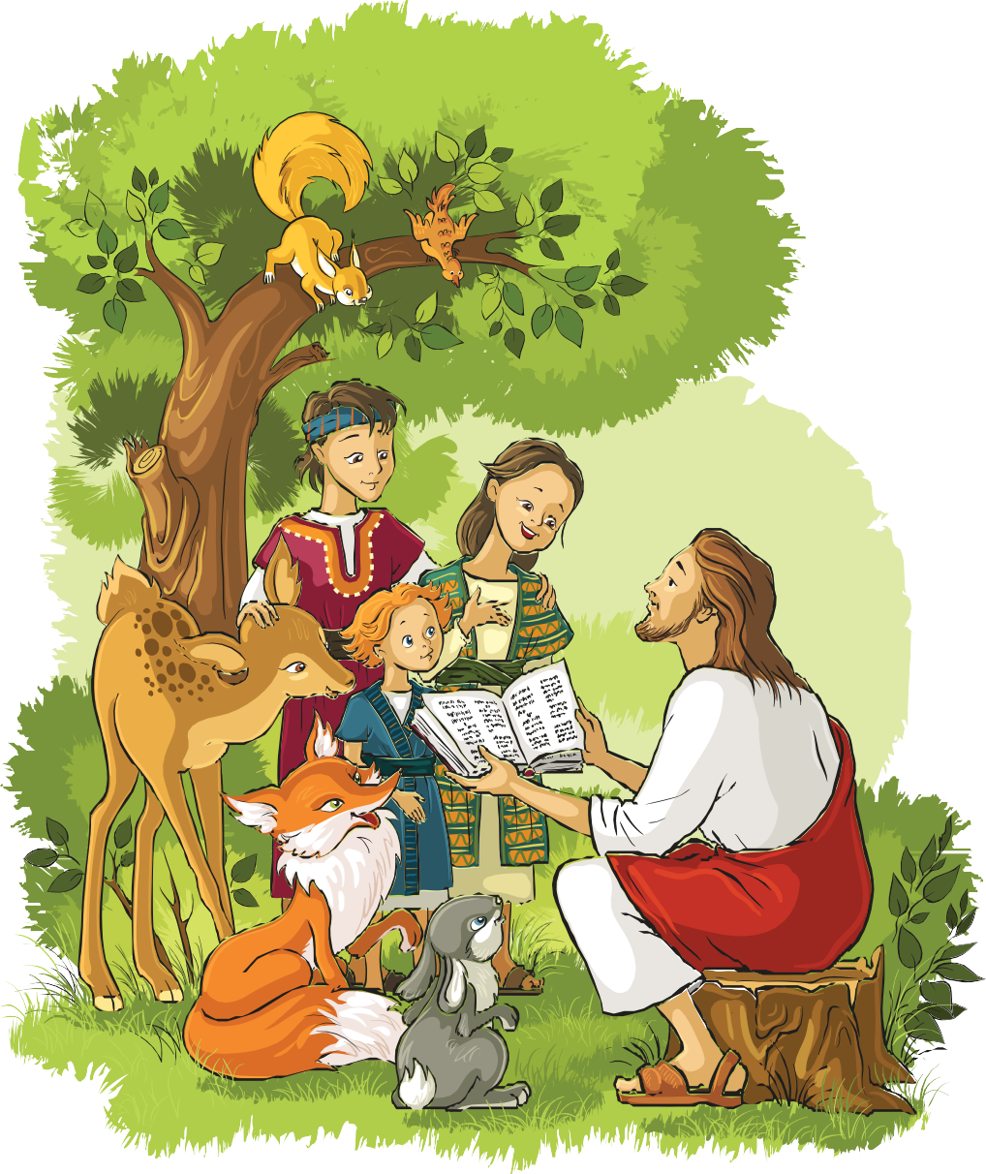
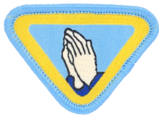
Complete the Prayer award
c.

- Explain why we pray and what things we pray for and how we pray. Read Isaiah 40:31

Isaiah 40:31: But they that wait upon the Lord shall renew their strength; they shall
mount up with wings as eagles; they shall run, and not be weary; and they shall walk,
and not faint.


Why do we pray?

What things do we pray for?

How do we pray?

- Read Matthew 6:5-15, the Lord’s Prayer.

Our Father, who art in heaven, Hallowed be thy name;
Thy kingdom come; thy will be done; on earth as it is in heaven.
Give us this day our daily bread.
And forgive us our trespasses, as we forgive those who trespass against us.
And lead us not into temptation; but deliver us from evil.
For thine is the kingdom, and the power and the glory, forever Amen

- Pray to God and Jesus 3 times a day for one week. Read 1 Thessalonians 5:17
1 Thessalonians 5:17 says: Pray without ceasing


Date started:

DAY 1: Morning Afternoon Evening

DAY 2: Morning Afternoon Evening

DAY 3: Morning Afternoon Evening

DAY 4: Morning Afternoon Evening

DAY 5: Morning Afternoon Evening

DAY 6: Morning Afternoon Evening

DAY 7: Morning Afternoon Evening

- Teach someone you know about praying and say a prayer with him/her.
Name:

Prayer:

- Do three (3) or more of the following & record what you did below:
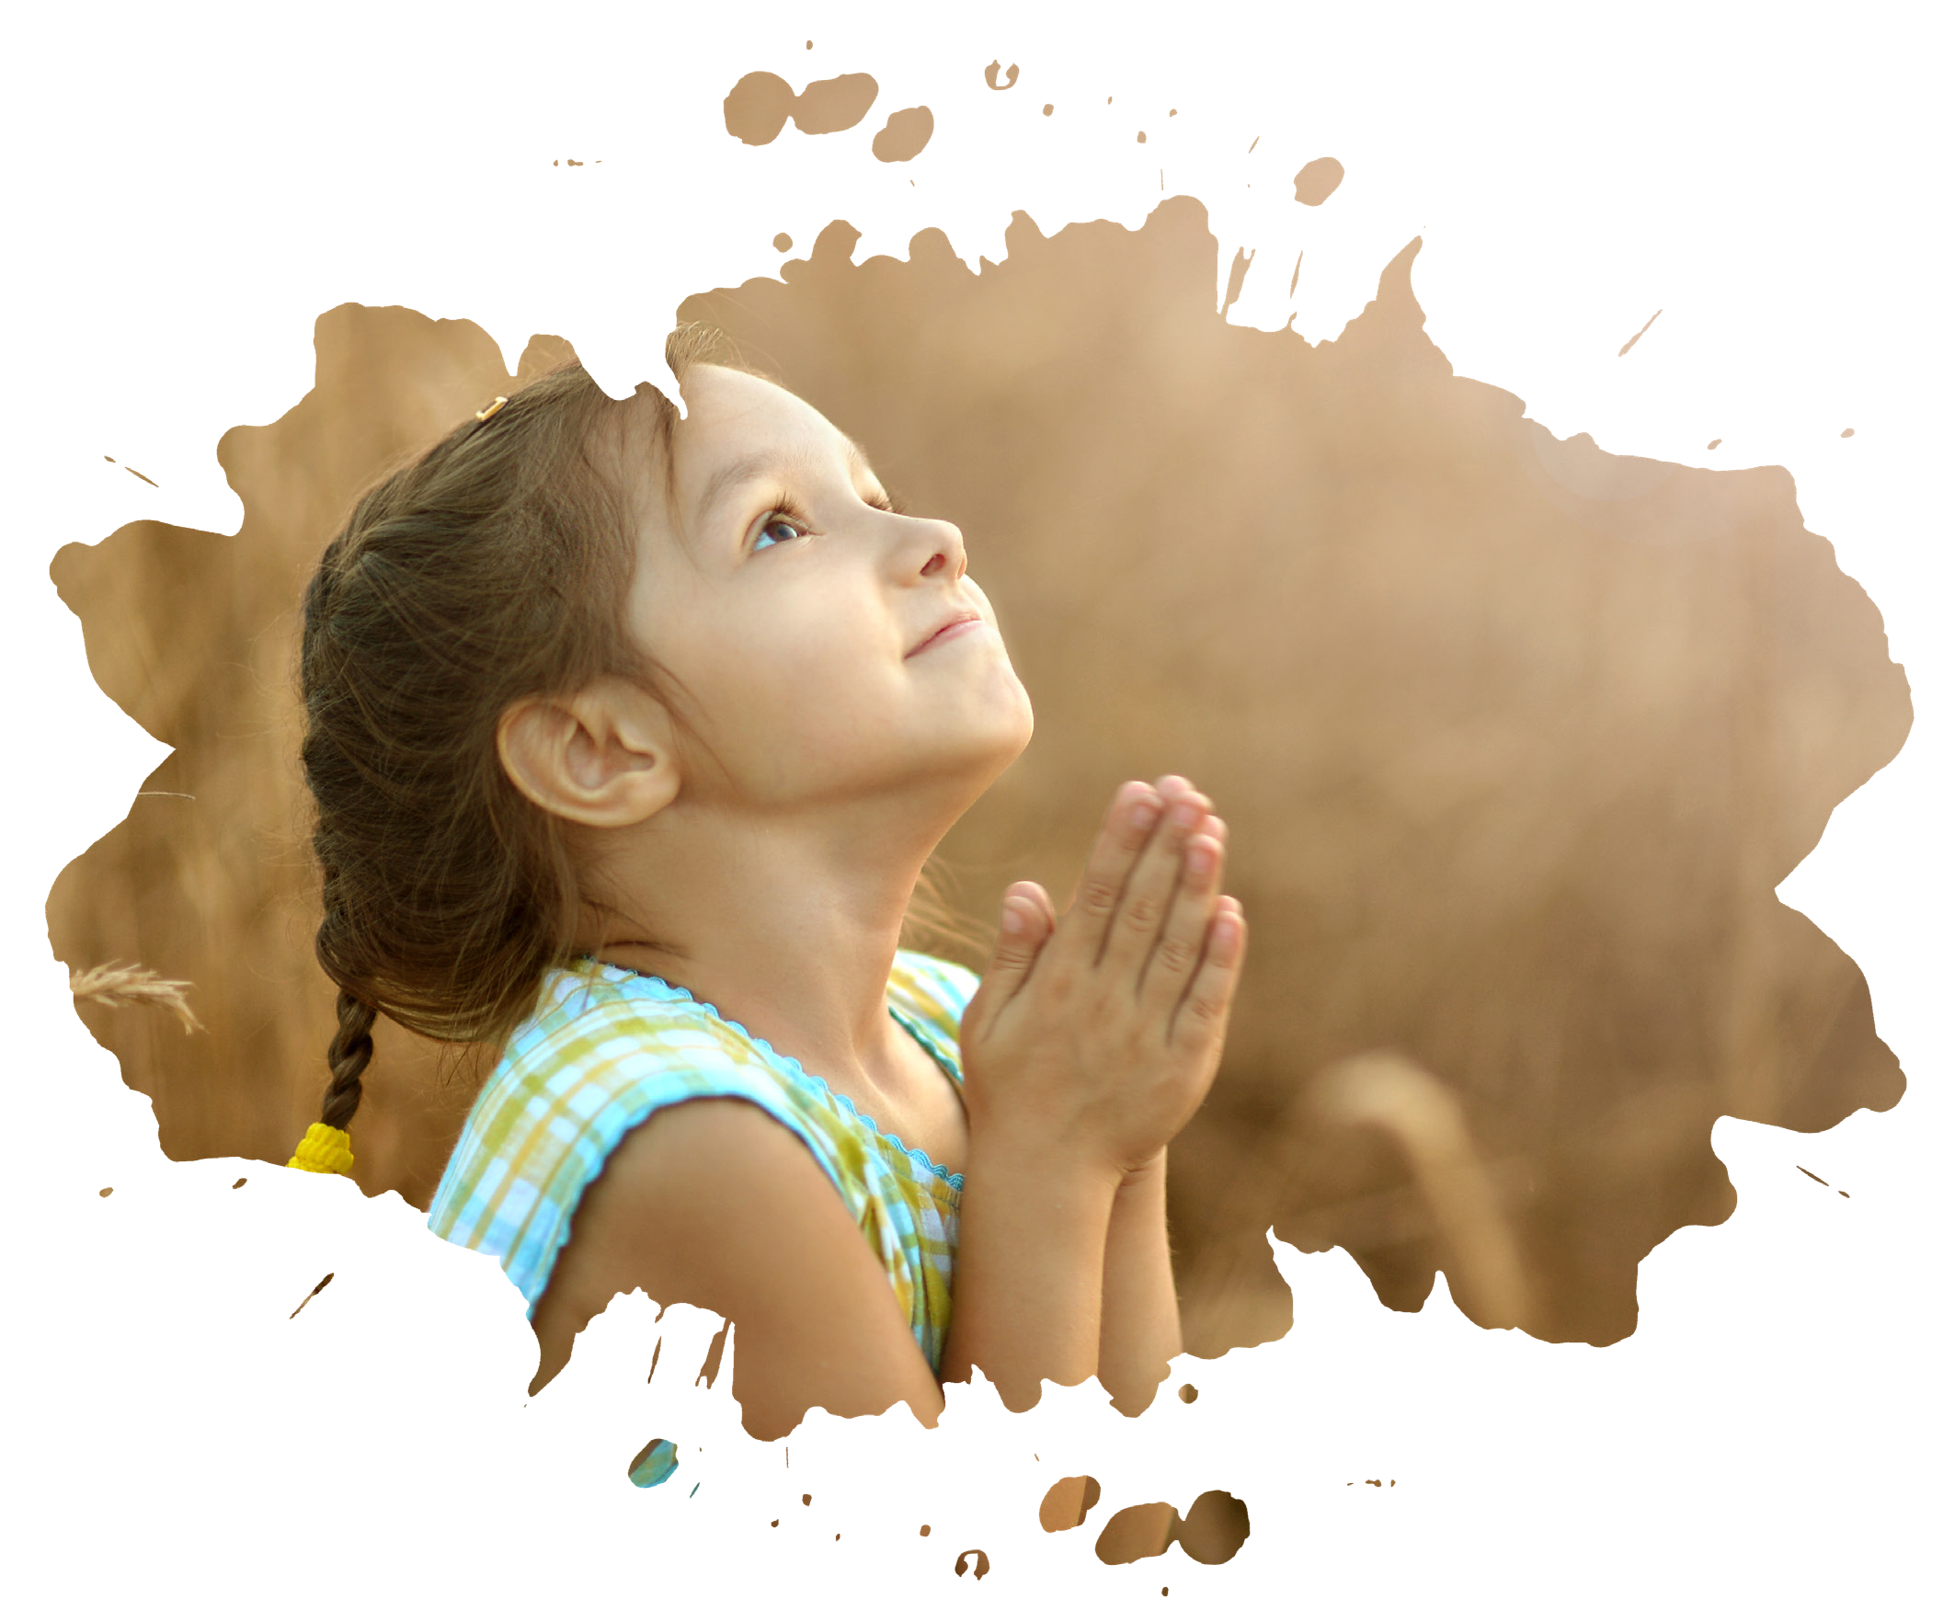
  - Make a prayer request chart and ask people if they have a prayer request and pray for them.
  - Lead out in a club opening or closing prayer.
  - Make a card with a prayer in it and give it to someone.
  - Ask the Pastor about prayer.
  - Have a prayer breakfast for kids and parents.
  - Make a prayer journal and see how God answers prayer.



18 Builder Workbook
|
The Prayer



Begin with prayer & thanksgiving (thumb)
Matthew 6:9 Pray then like this: “Our Father in heaven, hallowed be your name.

Pray for God’s will & for opportunities for ministry (index finger)
Matthew 6:10 Your kingdom come, your will be done, on earth as it is in heaven.

Pray for God to provide your needs, spiritual & physical (middle finger) Matthew 6:11 Give us this day our daily bread.

Ask for forgiveness, and pray for others who have mistreated you (ring finger) Matthew 6:12 and forgive us our debts, as we also have forgiven our debtors.

Pray for spiritual growth and the power of the Spirit of God to lead us and deliver us (pinkie)
Matthew 6:13 And lead us not into temptation, but deliver us from evil.

Put together a scrapbook, poster, or collage, showing some things you can do
to serve God and others.
1



What did you do?



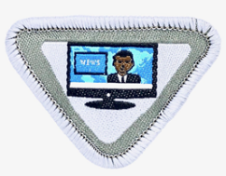
Complete the Media Critic award
2

- Explain what is meant by the term “media.” Cite four examples. ________________
_______________________________________________________________
_____________________________________________________________
_____________________________________________________________
_____________________________________________________________

- Memorise Philippians 4:8 and discuss three principles that help us form good reading, viewing and listening habits. ________________________________________
_____________________________________________________________
_____________________________________________________________
_____________________________________________________________
_____________________________________________________________
_____________________________________________________________

Philippians 4:8
“Finally, brethren, whatever things are , whatever things are
, whatever things are , whatever things are
, whatever things are , whatever things are of
, if there is any and if there is any- thing praiseworthy— on these things.”


Sat
Fri
Thu
Wed
Tue
Mon

- Keep a log of the time you spend each day with the different types of media. Note whether the media is Christ-centered or secular. Do this for two weeks.
Media Time Log
Sun

Week 1 | Week 2

- Do one of the following with an adult then become a “media critic” and discuss the merits of each:
  - watch television
  - read a story
  - listen to a recording


- With an adult, use a television guide, book club listing, etc., to choose what you will read or watch next week.
________________________________________________________________________________________________________________________________________________________________________________________________________________________________________________________

- After your teacher reads the beginning of a short story, make up your own ending.



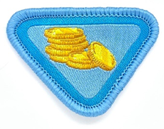
I Can Make Wise Choices

Complete the Wise Steward award
b.

- Find a Bible verse which tells who owns everything on earth. ____________________
_________________________________________________________________
- Describe a wise steward. _______________________________________________
__________________________________________________________________
- Find, read and explain Malachi 3:8-10. _____________________________________
__________________________________________________________________
________________________________________________________________
- Fill out your own tithe envelope and give it at church in the offering plate. ___________
________________________________________________________________

- Make a poster showing some of the things Sabbath School offerings are used for.
- Listen to the story of a widow in the Bible and her small offering. Record what you learnt.

- Tell how and why wise stewards will care for their belongings



I Can Care for My Body
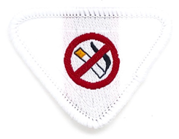

Complete the Temperance award
3

- Read and discuss:
  - 1 Corinthians 6:19-20 ___________________________________________
____________________________________________________________
_________________________________________________________
  - 1 Corinthians 3:17 ______________________________________________
____________________________________________________________
_________________________________________________________

- Tell what is meant by:

Drug abuse:

Temperance:



- Do one of the following:

  - Talk to a doctor/nurse or discuss with another adult the harm in using:
    - Tobacco
    - Alcohol
    - Other drugs


  - Watch and discuss a film or video on the dangers of using any of the above.

- Tell why some people choose to smoke, drink alcohol, or use drugs. Tell how we can choose not to use them ourselves.

- Plan a skit encouraging others to say “NO” and perform it with your group.



- Make an anti-smoking, anti-drug, or anti-alcohol design and paint it on a T-shirt. OR Create a poster showing the dangers of drug abuse.

- Identify two famous persons who do not use any tobacco, drugs, or alcohol, and who are among the best in their field. OR
Interview two people you know who live happily and healthfully without using tobacco, drugs, or alcohol, and discuss with them their reasons for not using those things.

MY FAMILY
I Have a Family


Share one way your family has changed. Share how these changes make you feel.
1


Find a story in the Bible about a family like yours (if possible).
Families Care for Each Other

Learn how to play a game through which each of your family members show appreciation to each of the other members of the family. (write below what
2
you did)


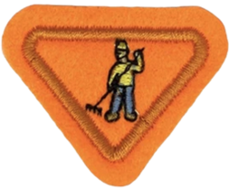
Complete the Family Helper award
b.

- Read and discuss the following Bible verses:
  - Philippians 2:14 ________________________________________________
____________________________________________________________
__________________________________________________________
  - John 15:12 ___________________________________________________
___________________________________________________________
__________________________________________________________
  - Psalm 118:7 __________________________________________________
___________________________________________________________
__________________________________________________________
  - Galatians 6:9 __________________________________________________
____________________________________________________________
__________________________________________________________

My Family Helps Me Care for Myself

- Who is a family helper?

- Discuss things I can do to be a helper.

- Keep a log for three (3) weeks listing how you have been a helper.

  - Each week, discuss with your mentor the progress you have made that week.

  - Discuss the ways you have helped and which was your favourite.


  - Discuss what ways you could have helped differently.

My Family Helps Me Care for Myself

Day 1

Day 2

Day 3

Day 4

Day 5
Week 1 | What I did: | What I did: | What I did: | What I did: | What I did:
Week 2
Week 3
Week 4

- Make a thank you card/note for your parent/guardian thanking them for everything they do for you. (stick photo of card in box below)

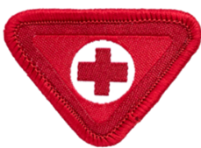
Complete the First Aid Helper award
3

- Demonstrate how to treat an abrasion or a cut, and describe the dangers of a dirty dressing.

- Describe how to care for a nosebleed.

- Identify and make a display of different types of bandages.

- Make a simple first-aid kit and learn uses of included items.

- Sterilise one of the following and tell why each is an important item to have in your first-aid kit.
  - Tweezers

  - Thermometer

  - Needle

- Visit an emergency-care facility to learn about some of the emergencies they care for.

- Play “hospital” and practice your skills on the above emergencies.
Date achieved:

Sign:

- Describe and draw the First Aid symbol.

- Name a time when Jesus gave first aid to someone who was bleeding badly.

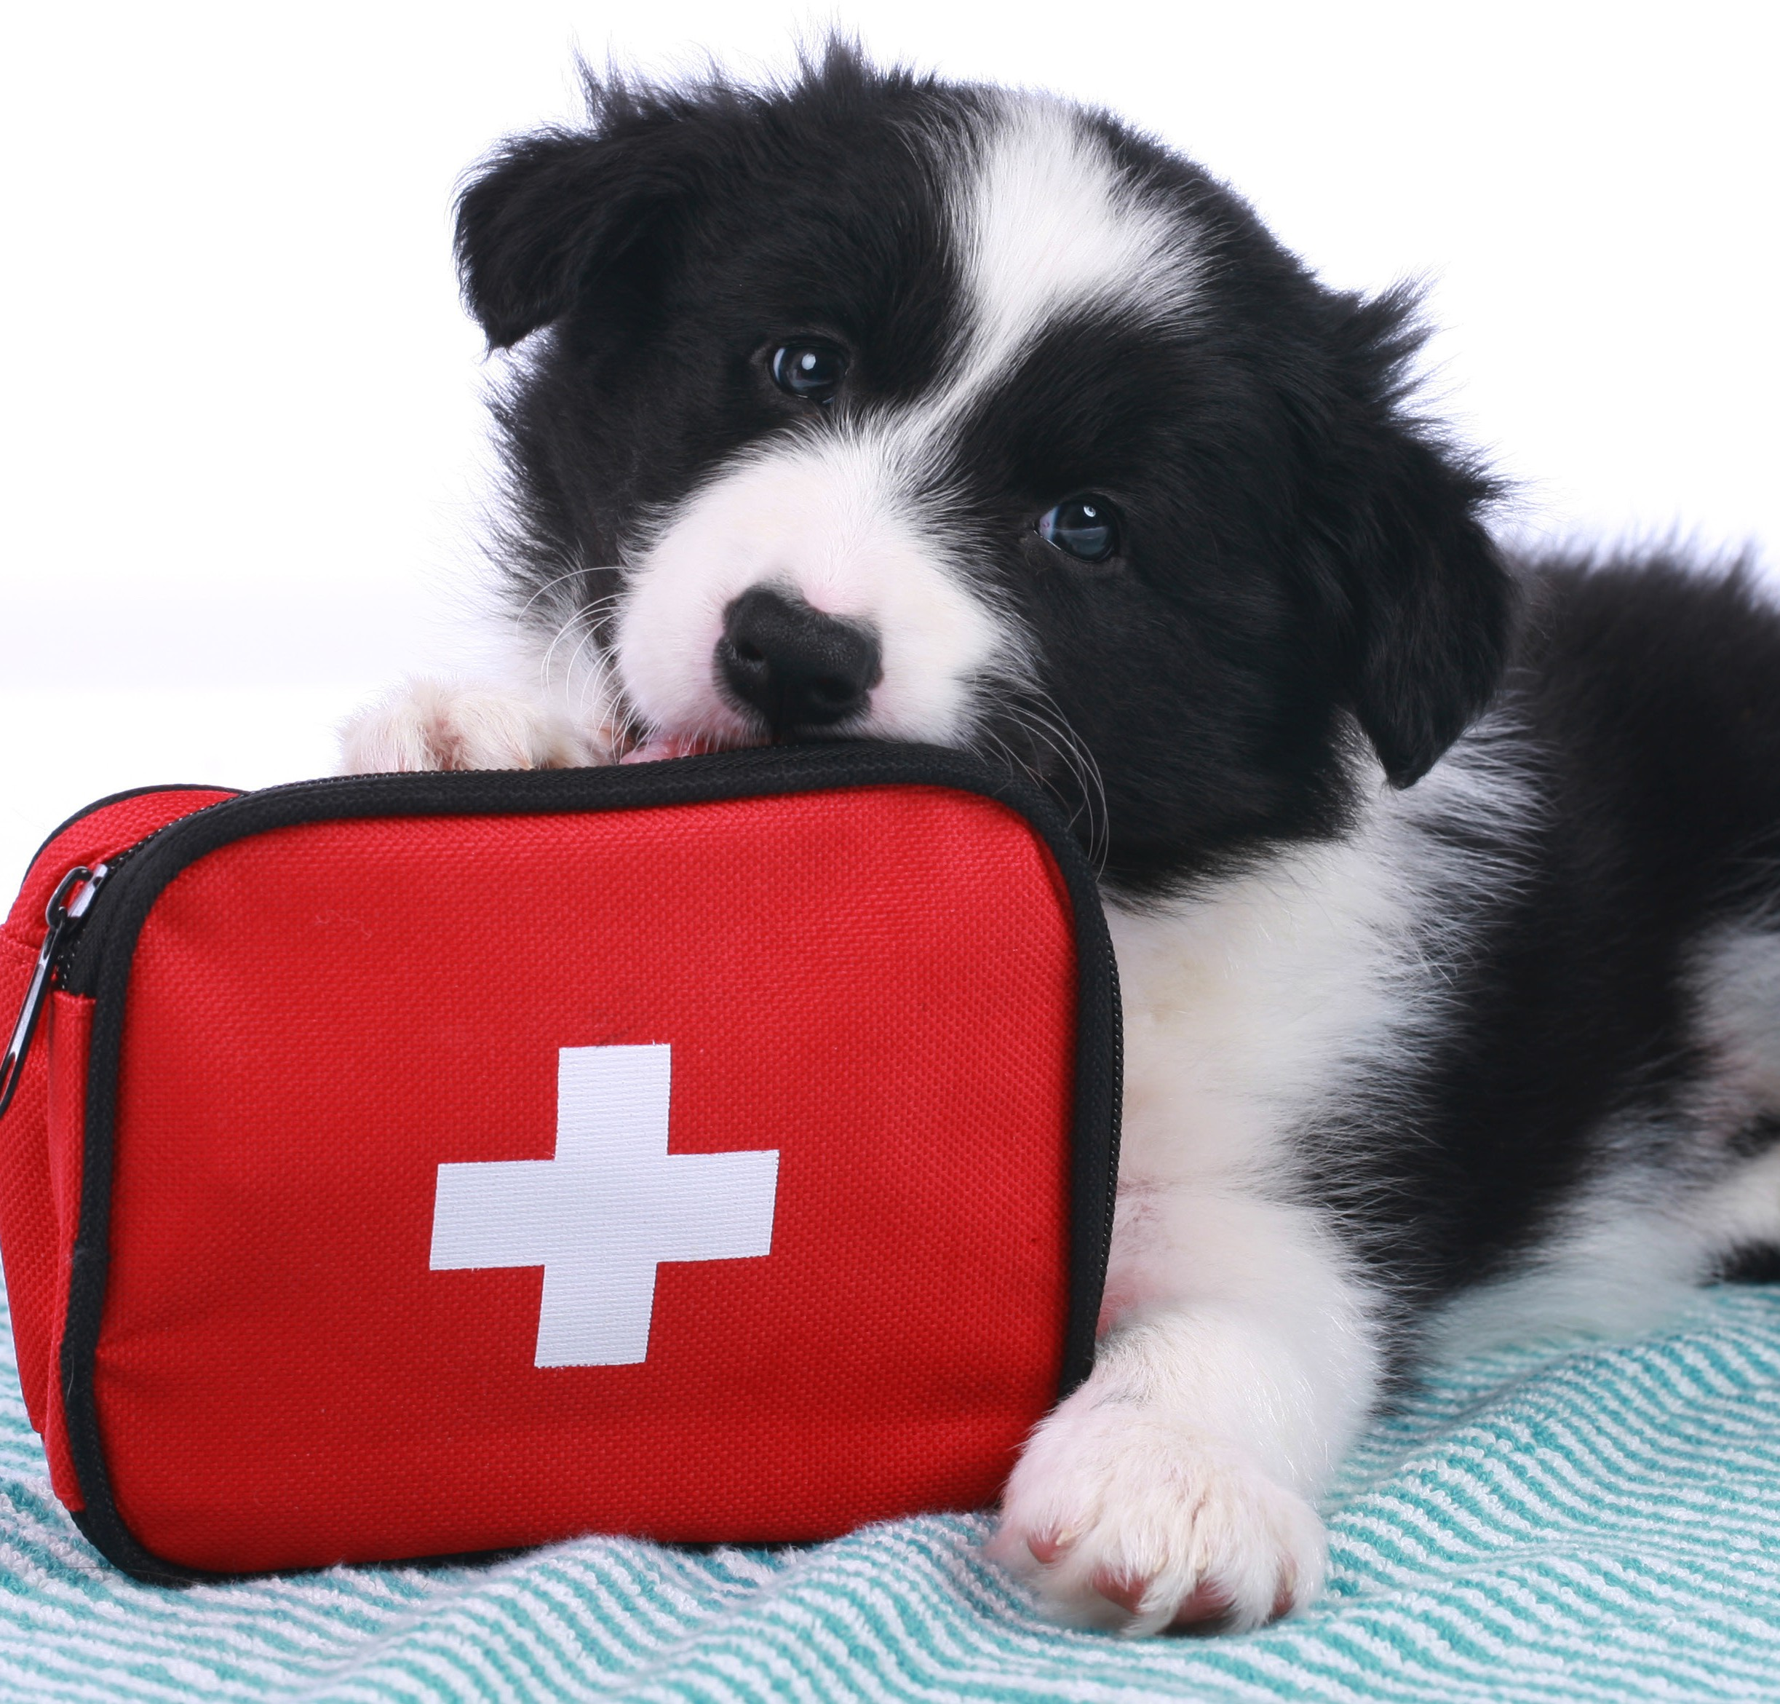

- Explain how you can be a Caring Friend. Find, read and memorise I Peter 5:7.
“Cast all your anxiety on him because he cares for you”

- Talk to a person and ask the following:
  - the day and month (s)he was born

  - his/her favourite animals

  - two of his/her favourite colors

  - three favourite foods

  - four things that are important to him/her

  - have your new friend tell you about his/her last trip

- Visit a shut-in or older person and take something to him/her. Use the questions in #2 as a basis for your conversation.
The World of Friends
- Tell one of the persons in #2 or #3 above how Jesus loves you and that He loves him/her also.

- Show how you can become a caring person to your parents by:
  - helping to keep your room clean

  - helping in the kitchen with preparation or cleanup

  - doing extra chores without being told

- Tell of something special you have done for a friend.


Name your country’s capital, and the leader of your country.



