
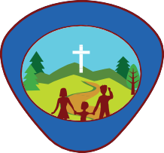
General Conference Youth Ministries Department

This book belongs to
L
T
C
U
R
E
R
A
D
V
E
B
U
N




Little Lamb


Activity Book










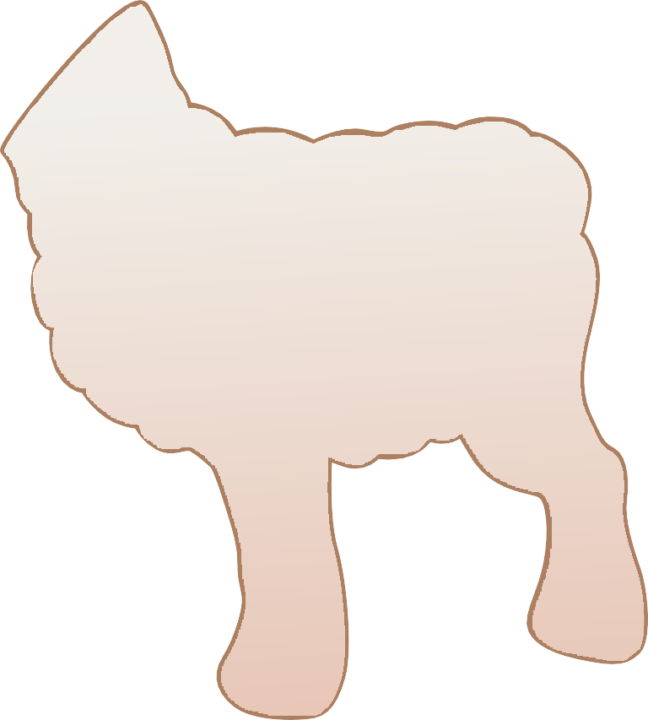


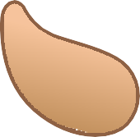












Little Lamb
Activity Book

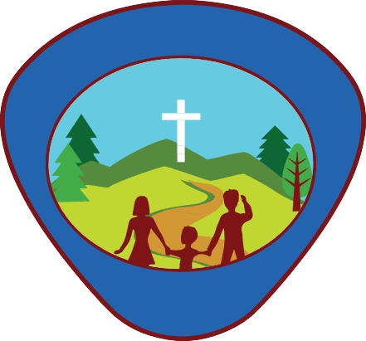
General Conference Youth Ministries Department
L
T
C
U
R
E
R
A
D
V
E
B
U
N

Produced by:
General Conference Youth Ministries Department 12501 Old Columbia Pike
Silver Spring, MD 20904

Departmental Director: Gary Blanchard Associate Youth Director: Pako Mokgwane Associate Youth Director: Andrés J. Peralta Editor-in-Chief: Andrés J. Peralta Departmental Advisor: Abner De Los Santos Senior Editorial Assistant: Kenia Reyes-de León

Project Manager: Mark O’Ffill
Content Contributors: Mark O’Ffill
Ted & Betsy Burgdorff

Copy Editor: Mark O’Ffill

Cover & Interior Designer:
Jonatan Tejel Isaac Chia
Adrian Gutierrez Perez
Wilbert Hilario (ClicArt) Had Graphic Inc.
hadgraphic@gmail.com

Photos by: © Shutterstock Resources:
Gomez, Ada. “Adventist Adventurer Awards.” Adventist Ad- venturer Awards - Wikibooks.org. North American Division Club Ministries, 2014. Web. 26 July 2017. <https://en.wiki- books.org/wiki/Adventist_Adventurer_Awards>.

Gooch, Jennifer A. Eager Beaver Leader’s Guide with 23 Themed Meeting Plans. 3rd ed. Lincoln, Neb.: Advent- Source, 2007, 2015. Print.

For information
Email: youth@gc.adventist.org Website: youth.adventist.org

Little Lamb Checklist

Name: Date Started: Date Completed:

Basic Requirements
My Family
Instructor Checklist

- Recite the Adventurer Pledge
- Complete the Story Listening I award
- Complete the Woolly Lamb award
My God
- God’s Plan to Save Me
  - Colour a story chart or lapbook about the following: The days of Creation
  - Tell an adult one of the stories of Creation: Creating animals, creating people, creating the Sabbath
- God’s Message to Me
  - Complete the My Friend Jesus award OR
  - Complete the Little Boy Jesus award
- God’s Power in My Life
  - Have a regular family worship time in your home. Keep a record.
  - Ask a parent or guardian what their favourite day of creation is.
  - Complete the Bible Friends I award.
My Self
- I Am Special
  - Complete the Finger Play award
- I Can Make Wise Choices
  - Complete the Sharing award
- I Can Care for My Body
  - Complete the Healthy Foods award
- I Have a Family
  - Complete the My Family award.
- Families Care for Each Other
  - Complete the Special Helper award
- My Family Helps Me Care for Myself
  - Complete the Healthy Me award
My World
- The World of Friends
  - Complete the Creation award.
- The World of Other People
  - Complete the Community Helpers award.
- The World of Nature
  - Complete at least two of the following Little Lamb level awards:
    - Bodies of Water,
    - Insects,
    - Stars,
    - Weather or
    - Zoo Animals

Other awards that may be earned by Little Lambs as time allows include:
    - Alphabet
    - Bible Friends
    - Colours
    - Music I
    - Numbers
    - Trains and Trucks
    - Trikes & Bikes
Basic Requirements
1.
2.
3.
My God
1.

2.

3.

My Self
1.
a.
2.
a.
3.
a.
My Family
1.
a.
2.
a.
3.
a.
My World
1.

2.

3.

Recite the Adventurer Pledge
1

“Because Jesus loves me, I will always do my best.”
Adventurer Pledge

Complete the Story Listening I award
2

1. Listen to two age-appropriate books, not read before, from the following categories:

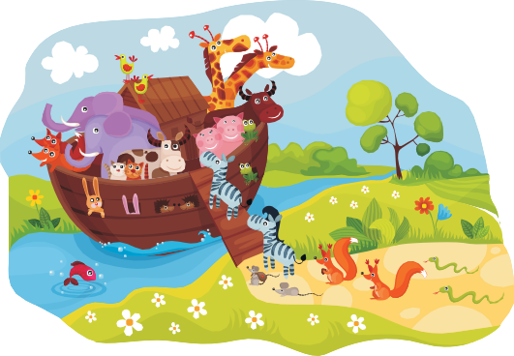
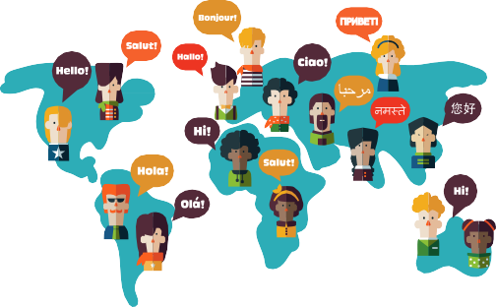
Bible
Missions




























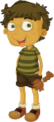

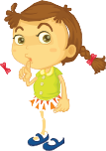


Friends and Family
Nature


BASIC

- 2. Tell the person who read to you what you like most about each story.

3. Tell the person who read to you “thank you” OR make a craft that you give them that tells them you are thankful. (Take a picture and post in the box below)


Thank You!!!

8 | Little Lamb Workbook

Complete the Woolly Lamb award
3

- 1. Listen to a book about lambs.

2. Say three things you learned about lambs. (Note taking area for adult care givers)

3. Play a game about lambs.

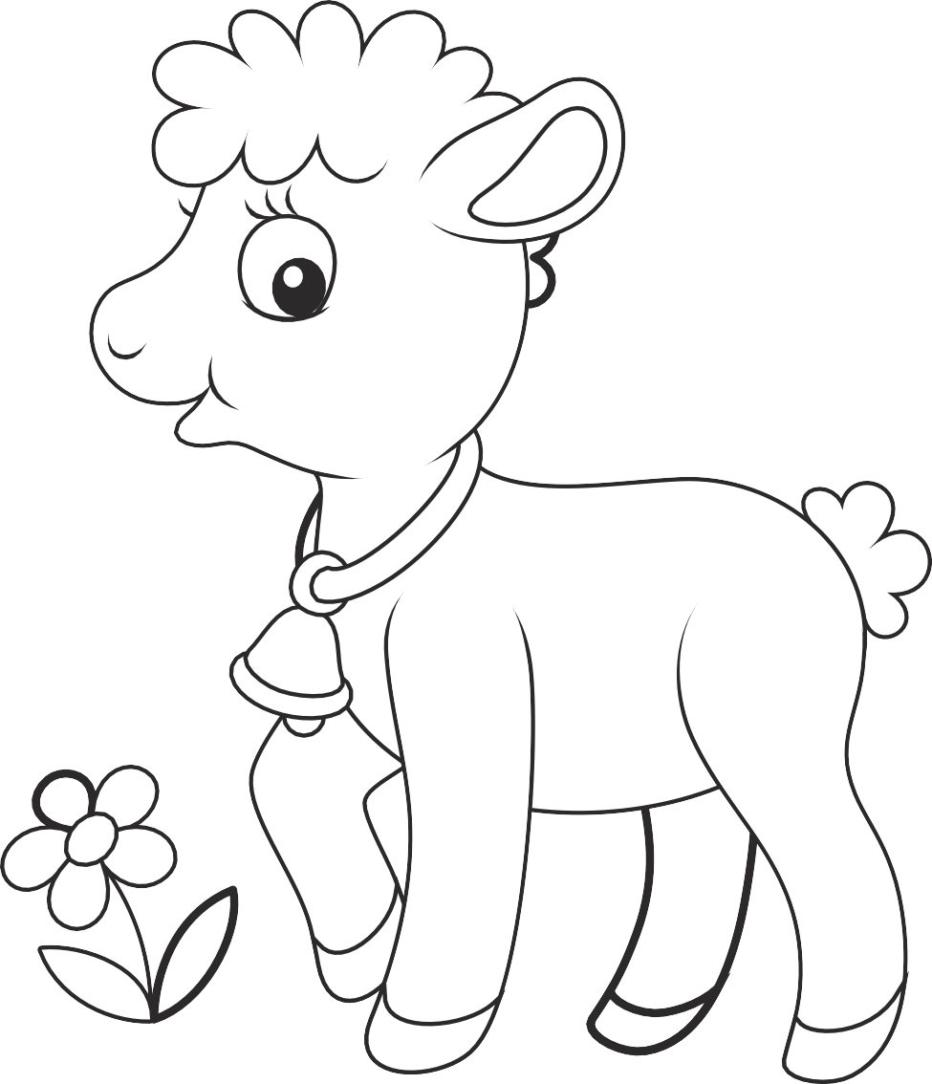

BASIC

4. Make a lamb craft.

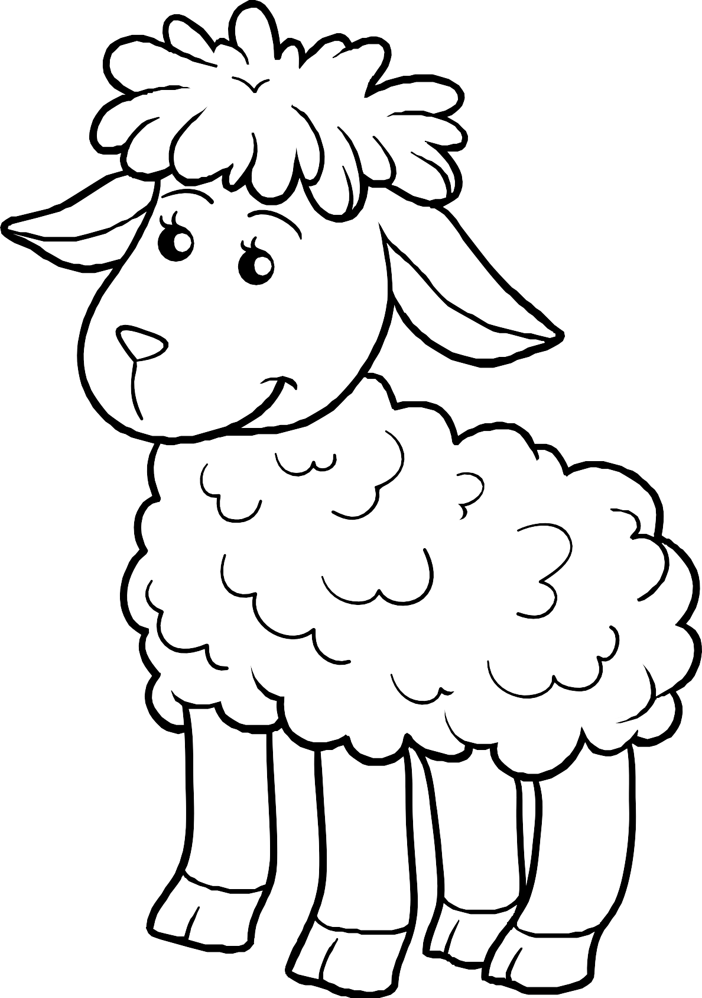

Colour a story chart or lap-book about: The Days of Creation.
1





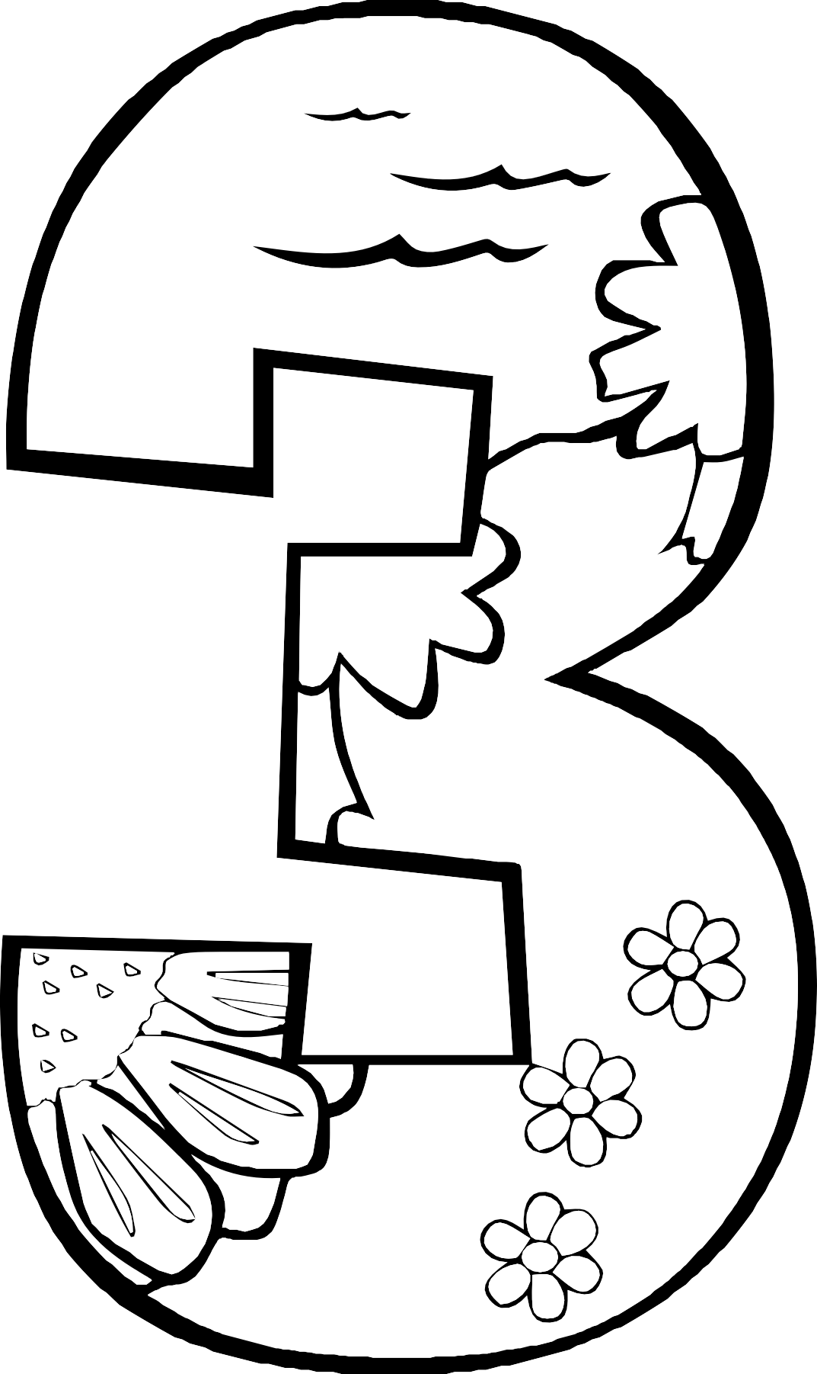



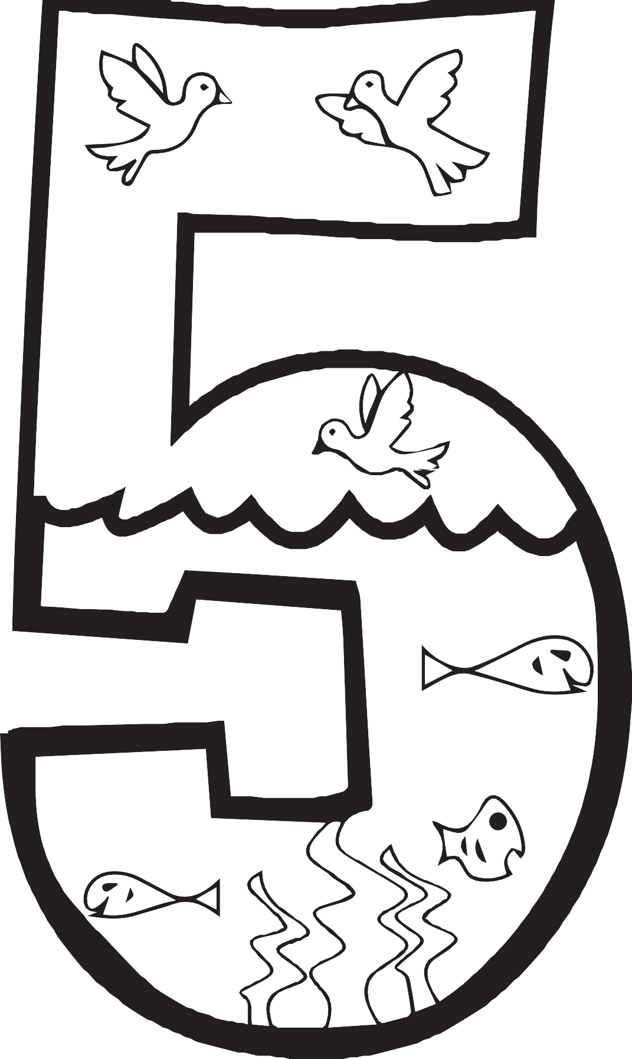

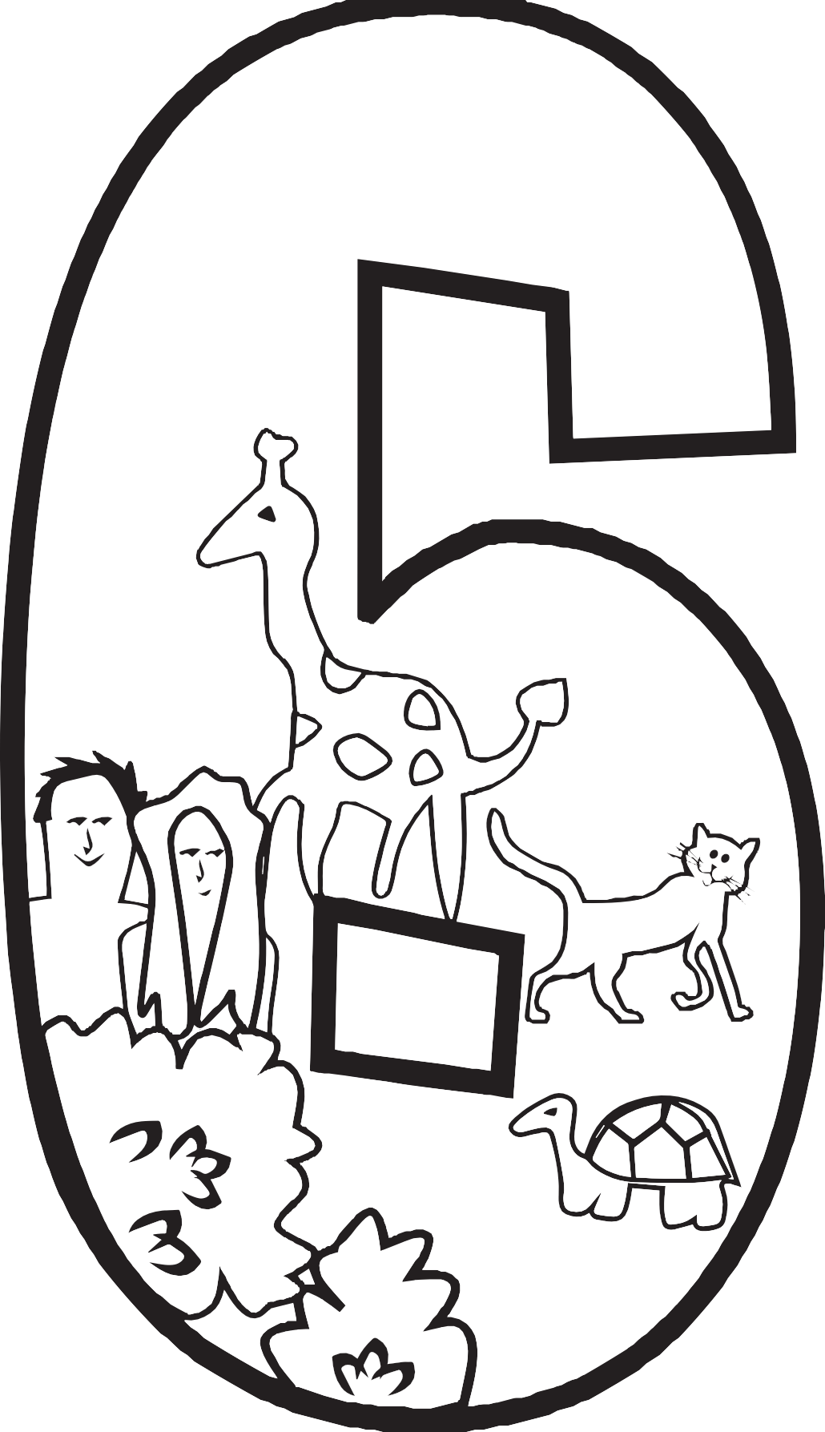

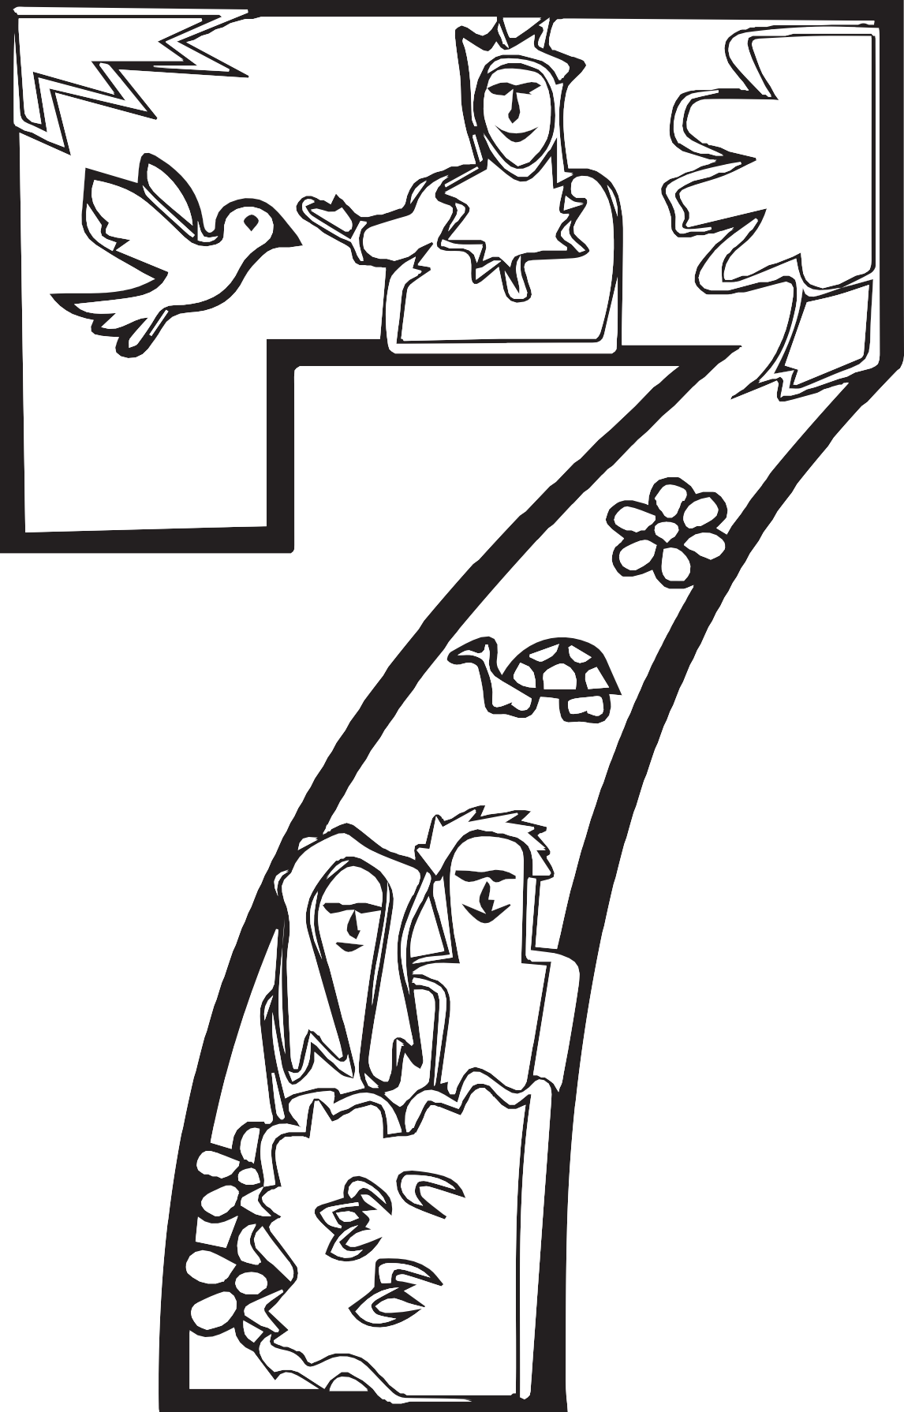

Tell an adult one of the stories of Creation: Creating animals, creating people,
creating the Sabbath.
b.

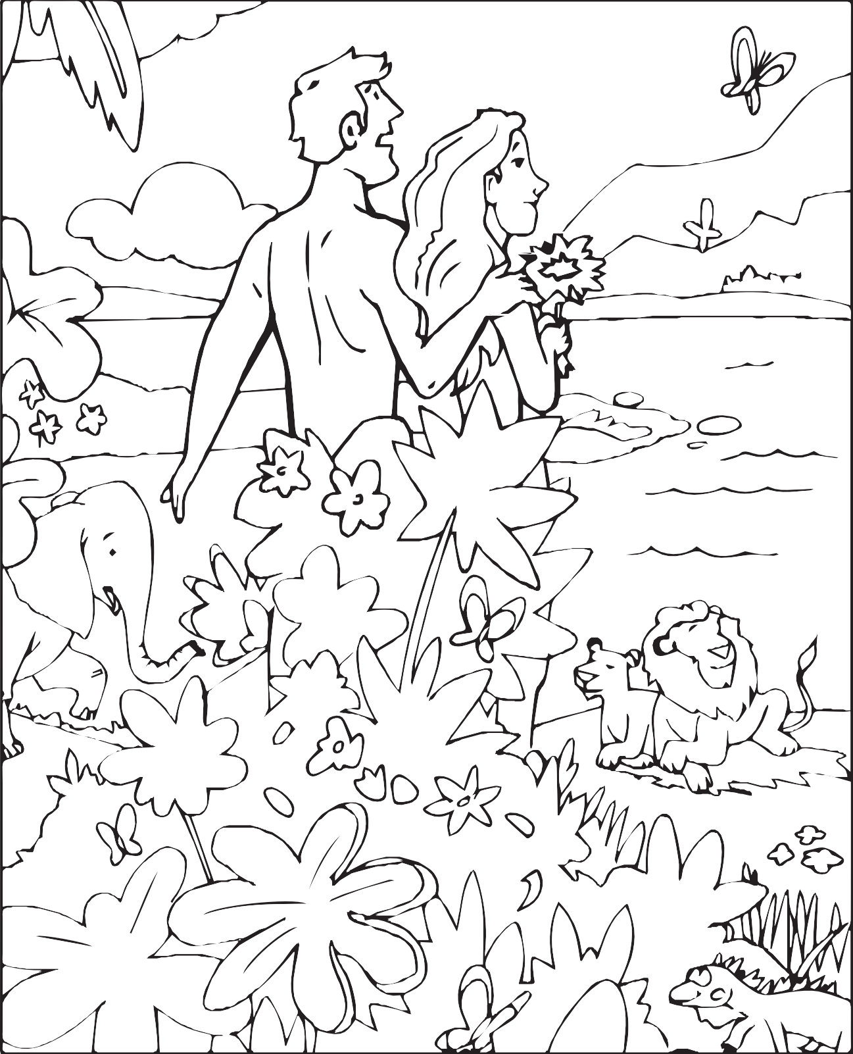

Complete the My Friend Jesus award OR Complete the Little Boy Jesus award (pg21).
2

- 1. Listen to a book about Jesus.
Book:

Who is Jesus to you? _________________________________

Date: Signed:

2. Sing a song about Jesus.

Write the first line of the song ____________________________

Date:
Signed:
- 3. Play a game about Jesus.

4. Learn how Jesus grew up helping/obeying his parents.

5. Learn to be friends with peers as Jesus was.

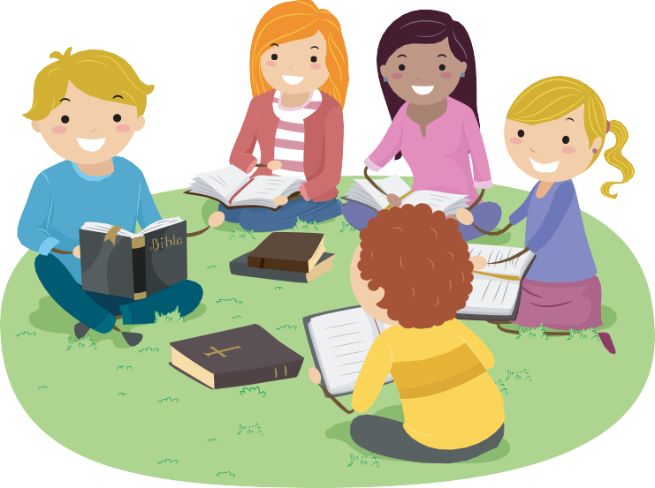

- 6. Make a friend craft.

Trace your hand and a friend’s hand, and colour it.

Complete the Little Boy Jesus award.
b.

1. Listen to a book about little boy Jesus.

2. Sing a song about little boy Jesus. (Write the title of the song)



3. Play a game about little boy Jesus. (Write the title of the game you played)

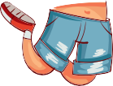


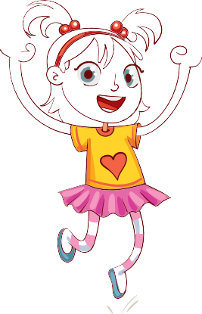



Jesus obedient
was

in wisdom
grew

4. Make a little boy Jesus craft. (Record on a separate sheet/card)

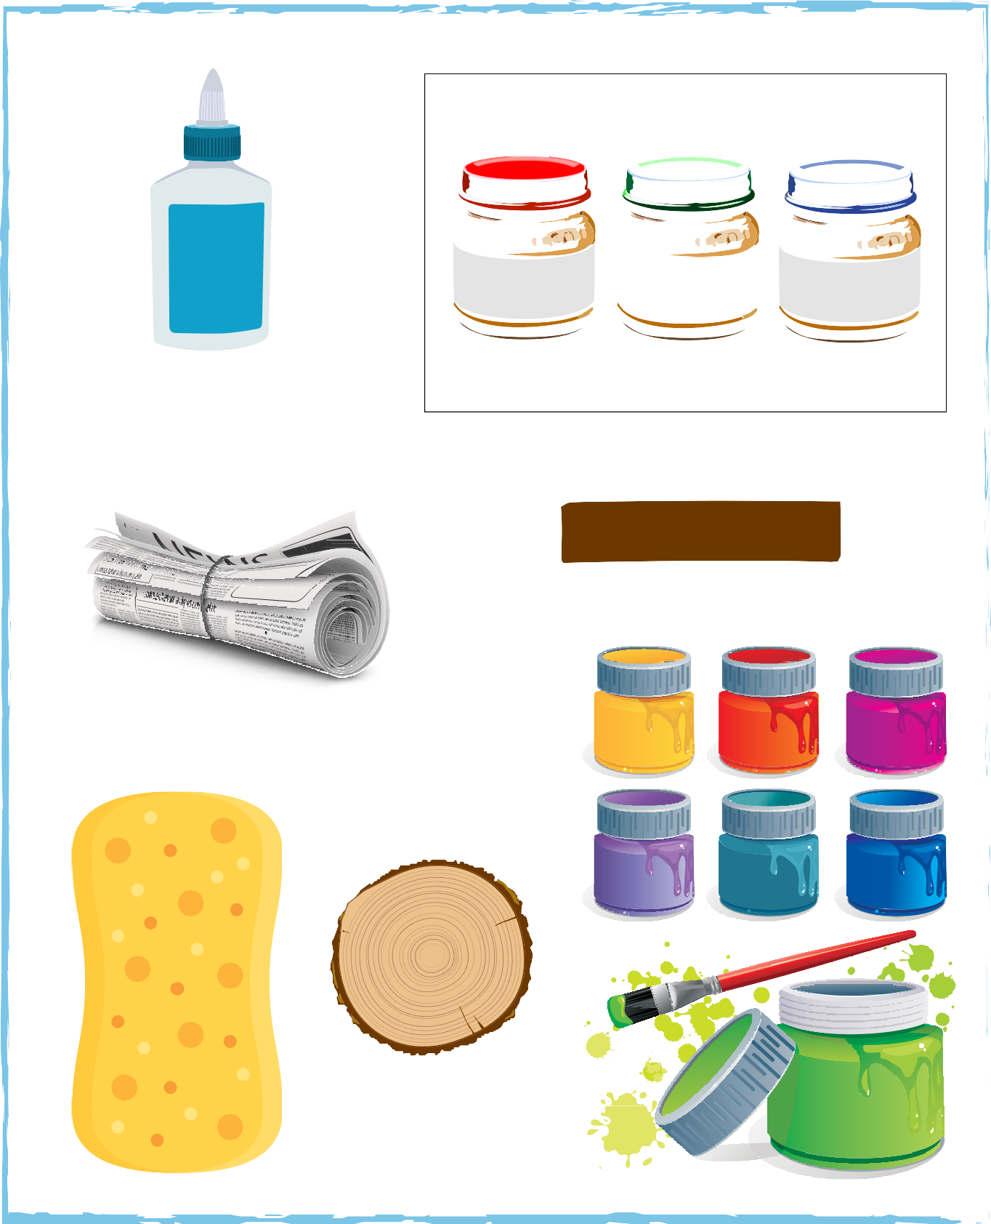

Sat
Fri
Thu
Wed
Tue
Mon

Have a regular family worship time in your home. Keep a record.
3

FAMILY worship TIME RECORD
Sun

Week 1 | Week 2 | Week 3 | Week 4

MY GOD
God’s Power in My Life

Ask a parent or guardian what their favourite day of creation is.
b.

Complete the Bible Friends I award.

1. Listen to a book about Bible friends.

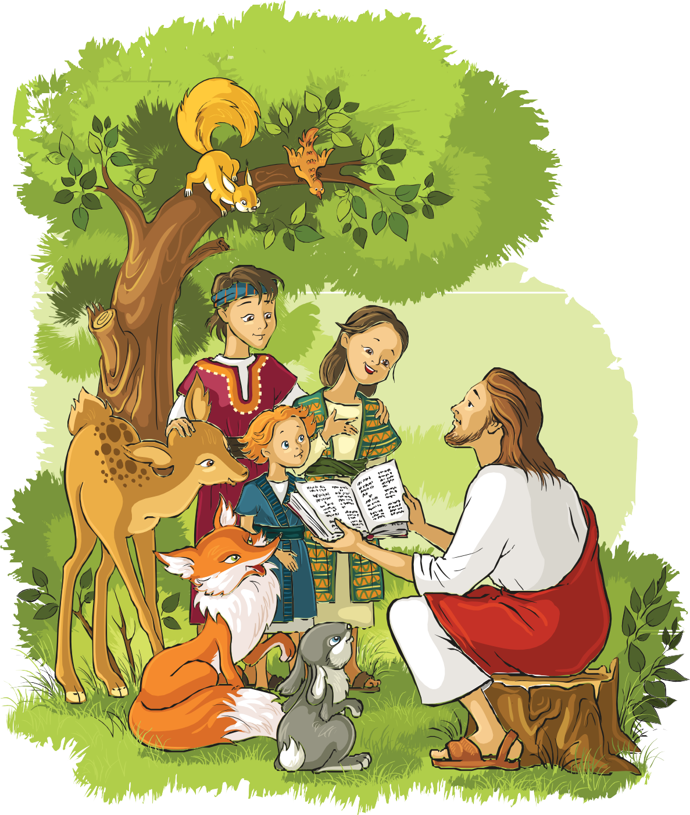

- 2. Sing a song about Bible friends. (Write the title of the song)

- 3. Play a game about Bible friends. (Write the title of the game)

- 4. Make a Bible friend craft. (Record on a separate sheet/card)

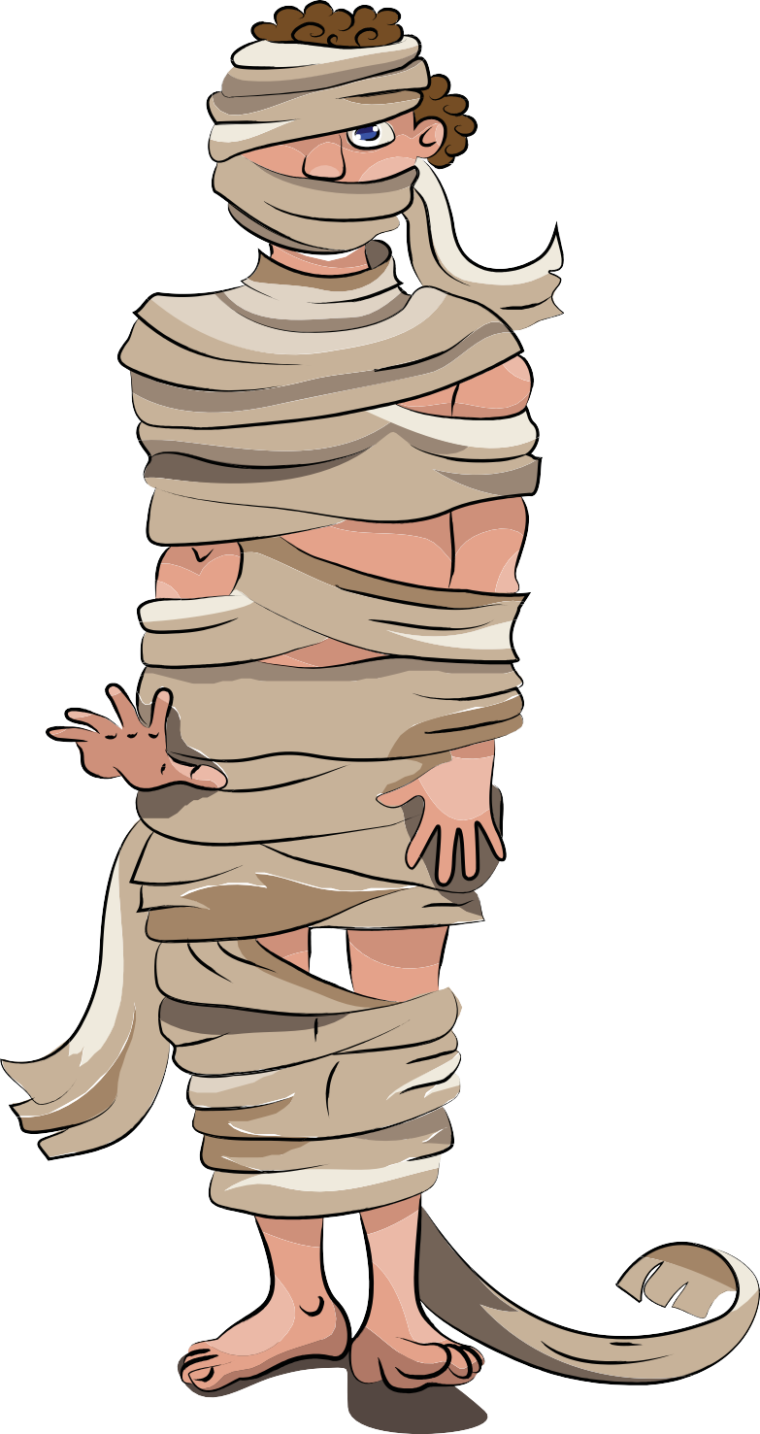

Complete the Finger Play Award.
1

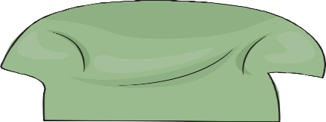
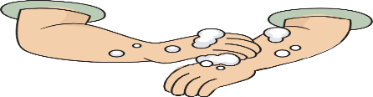
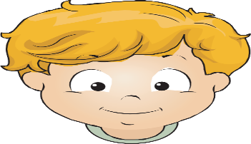
- 1. Listen to a story about hands. (Write the title of the story you listen to watch on video)

Date:

2. Say three things you learned about hands.

I Am Special
MY SELF

- 3. Say a poem and use your hand to act it out.



4. Make a craft that uses your hands as part of the project. (i.e., finger-paint, trace hands)

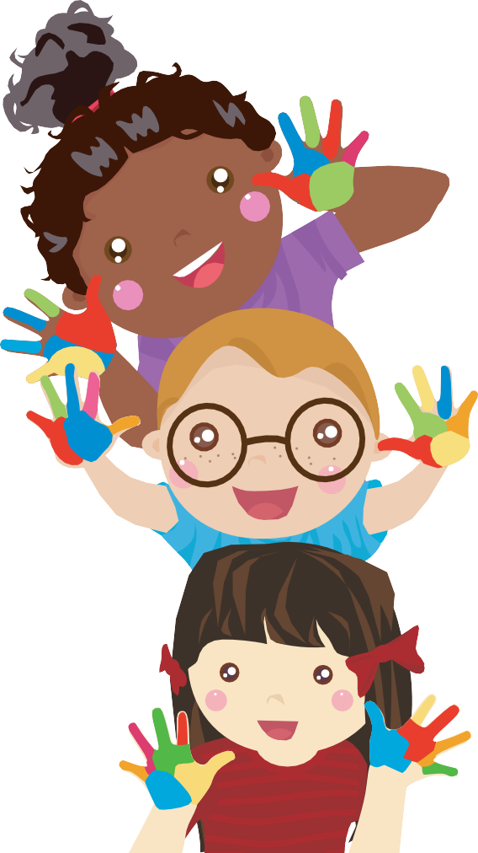

5. Complete an activity using your fingers. (i.e., build something with blocks, knead bread.)


I Can Make Wise Choices
MY SELF

Complete the Sharing Award.
2

- 1. Listen to a book about sharing.
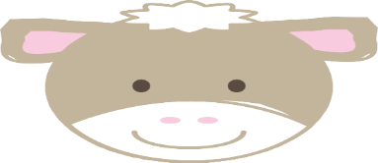

2. Sing a song about sharing.

MY SELF
I Can Make Wise Choices

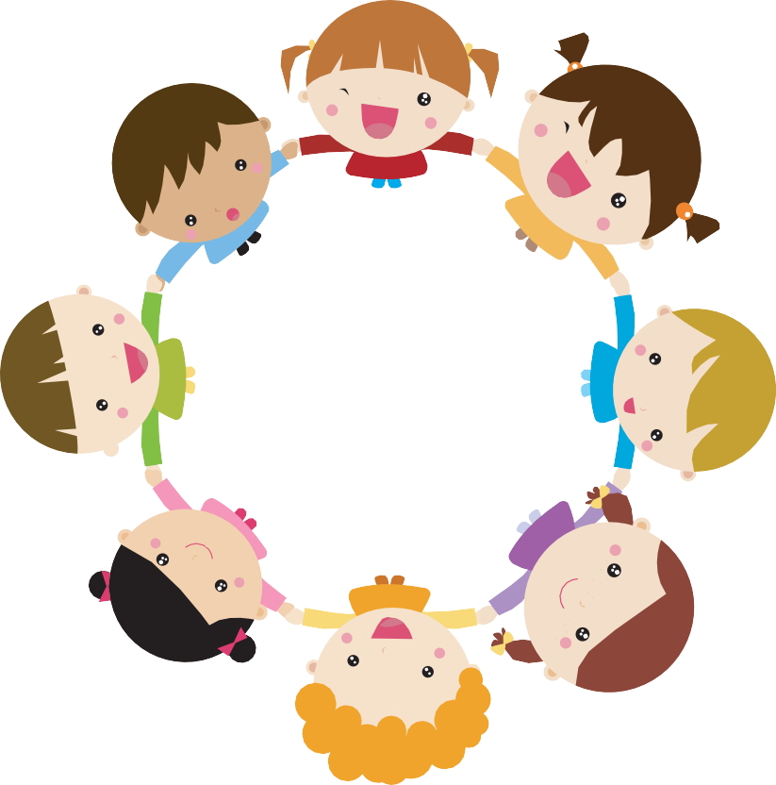
- 3. Play a game about sharing.

4. Make a craft and share it with someone. (Write what you did and who you shared it with)
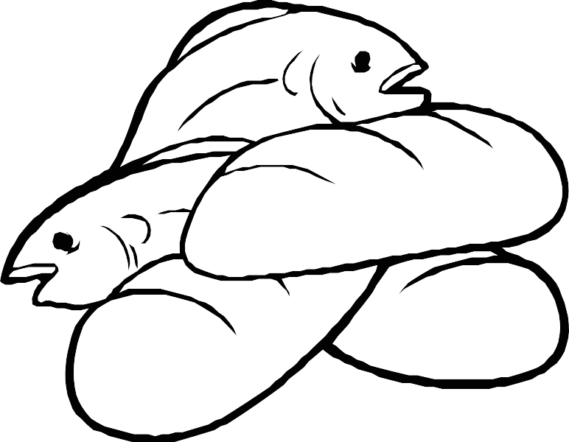

Complete the Healthy Foods Award.
3

1. Listen to a book about healthy foods.


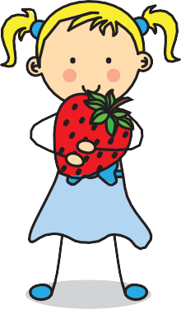
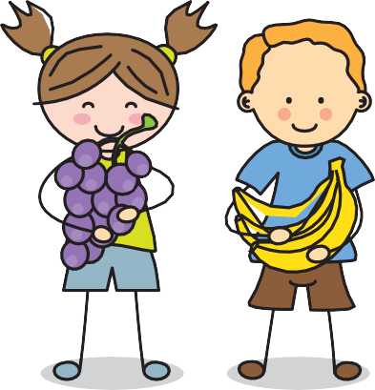
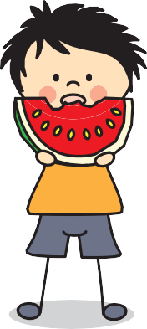

2. Say three things you learned about healthy foods. (Note taking area for adult care givers)










MY SELF
I Can Care for My Body

3. Play a game about healthy foods.

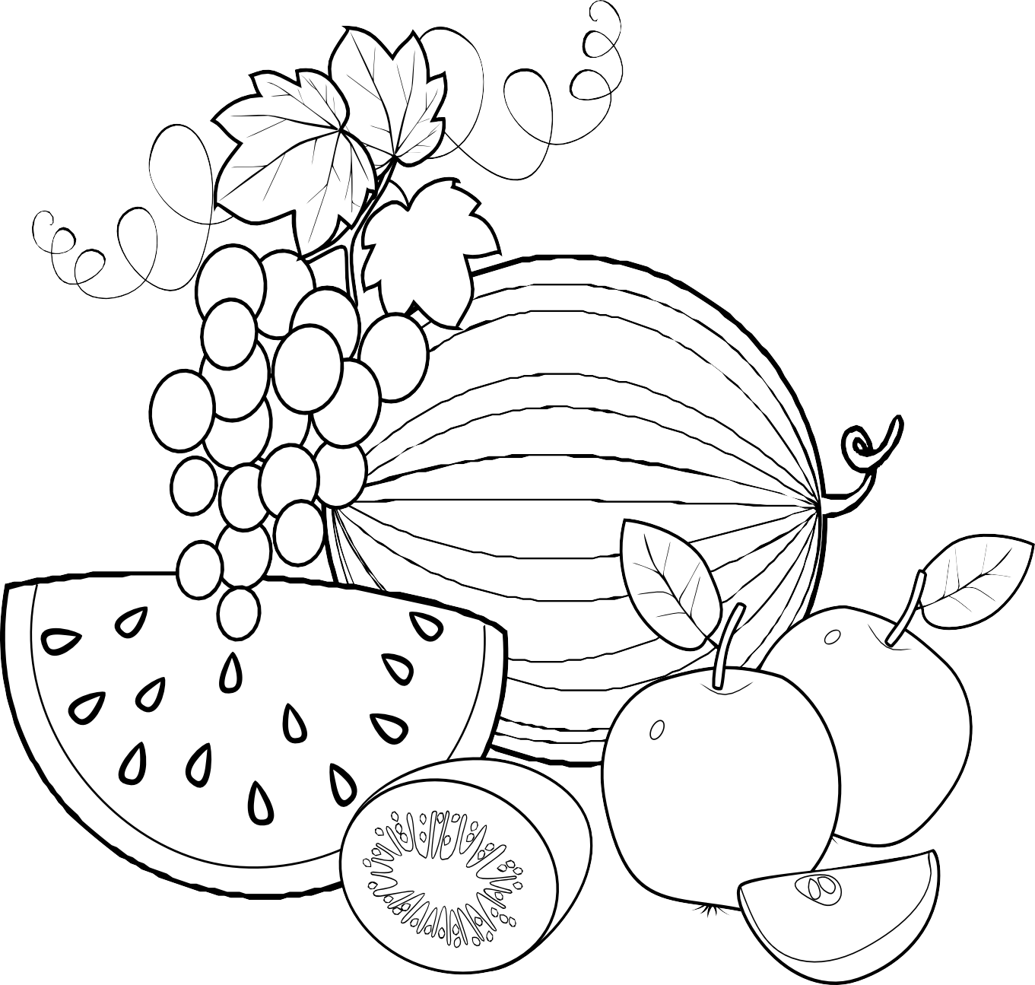

4. Make a healthy foods craft or chart.

Complete the My Family award.
1

- 1. Sing a song about families.


2. Listen to a story about families.

Story:

“I ____________________ my family “

Date:
Signed:
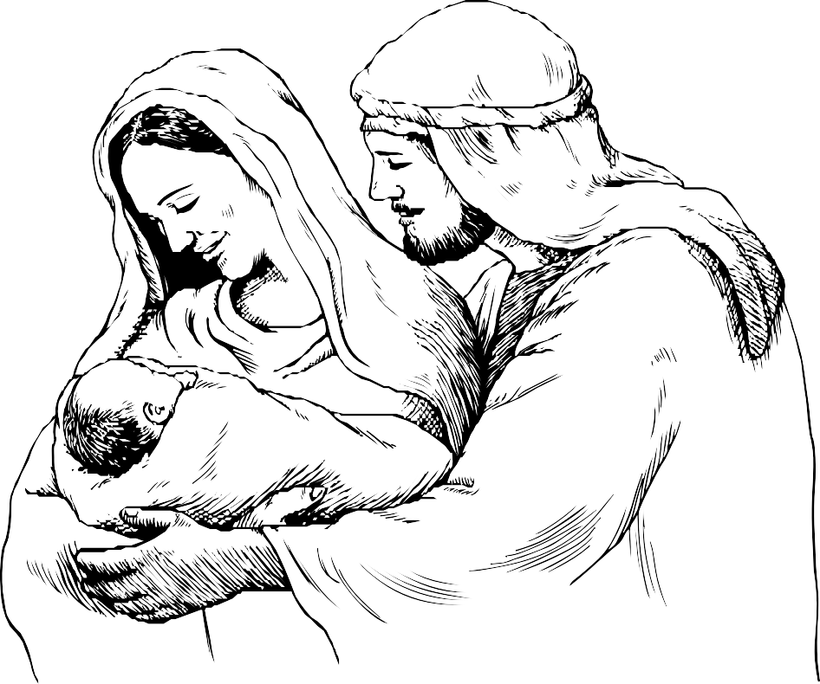

I Have a Family
MY FAMILY

3. Say three things you learned about families. (Note taking area for adult care givers)

4. Make a craft about families.

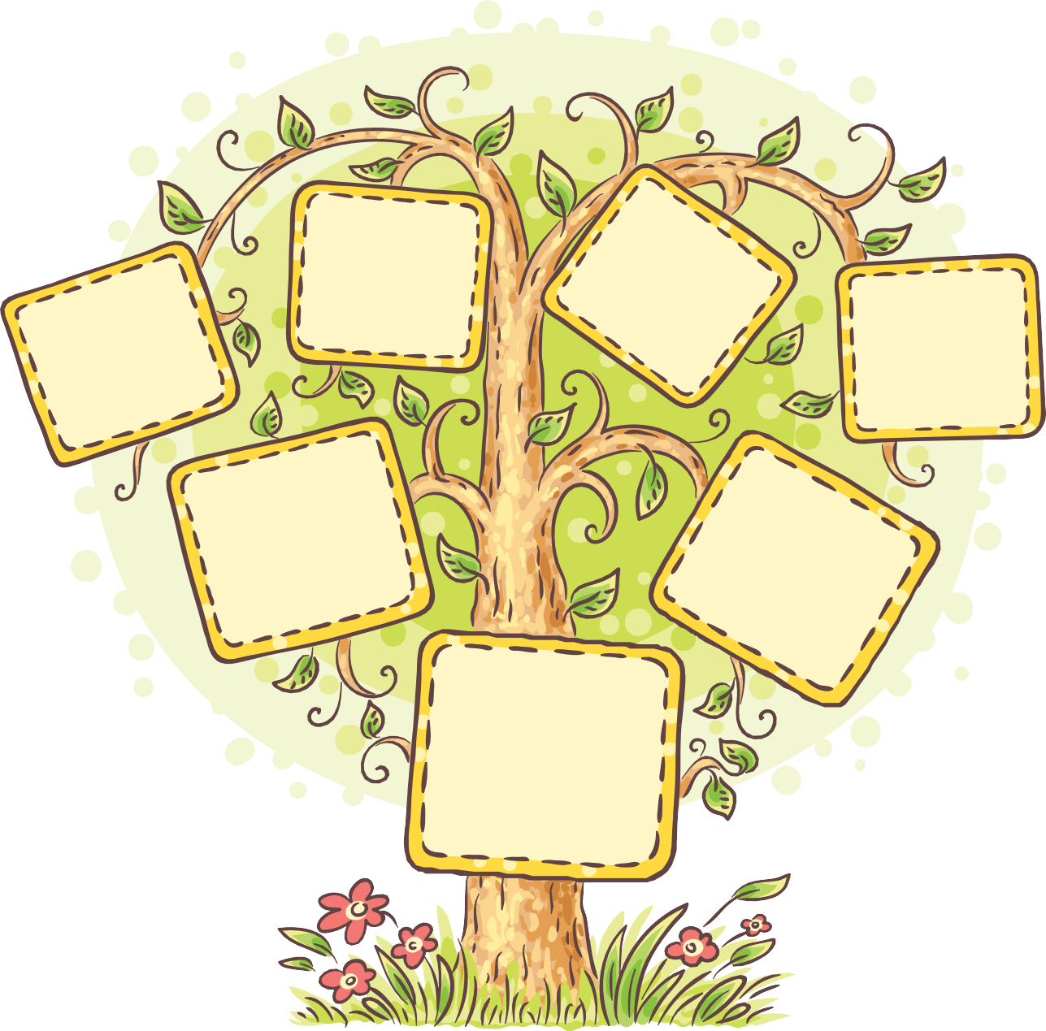

5. Complete an activity about families.

Families Care for Each Other
MY FAMILY

Complete the Special Helper award.
2

- 1. Listen to a book about being helpful.

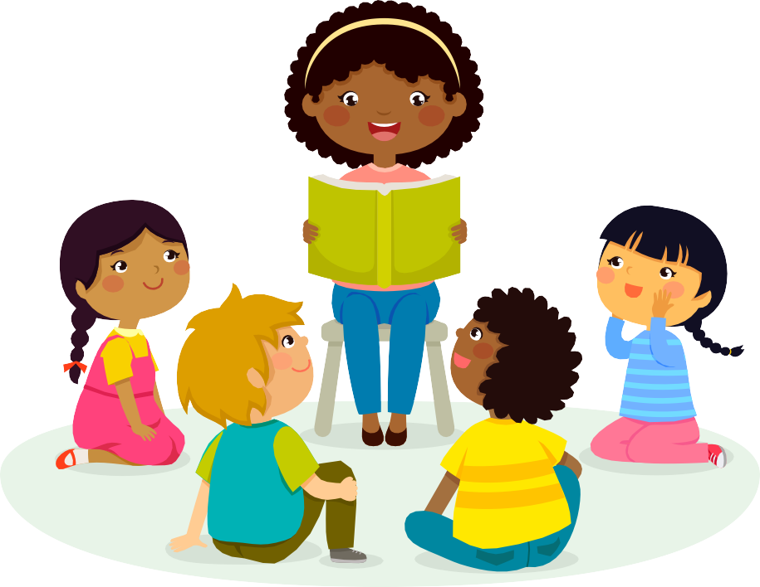

- 2. Sing a song about being helpful.

3. Play a game about being helpful.

- 4. Make a craft about being helpful.

5. Help a family member with a special chore for one week. (i.e., feed a pet)

DAY | TASK/CHORE COMPLETED
Sunday
Monday
Tuesday
Wednesday
Thursday

Friday

Saturday | Day of rest
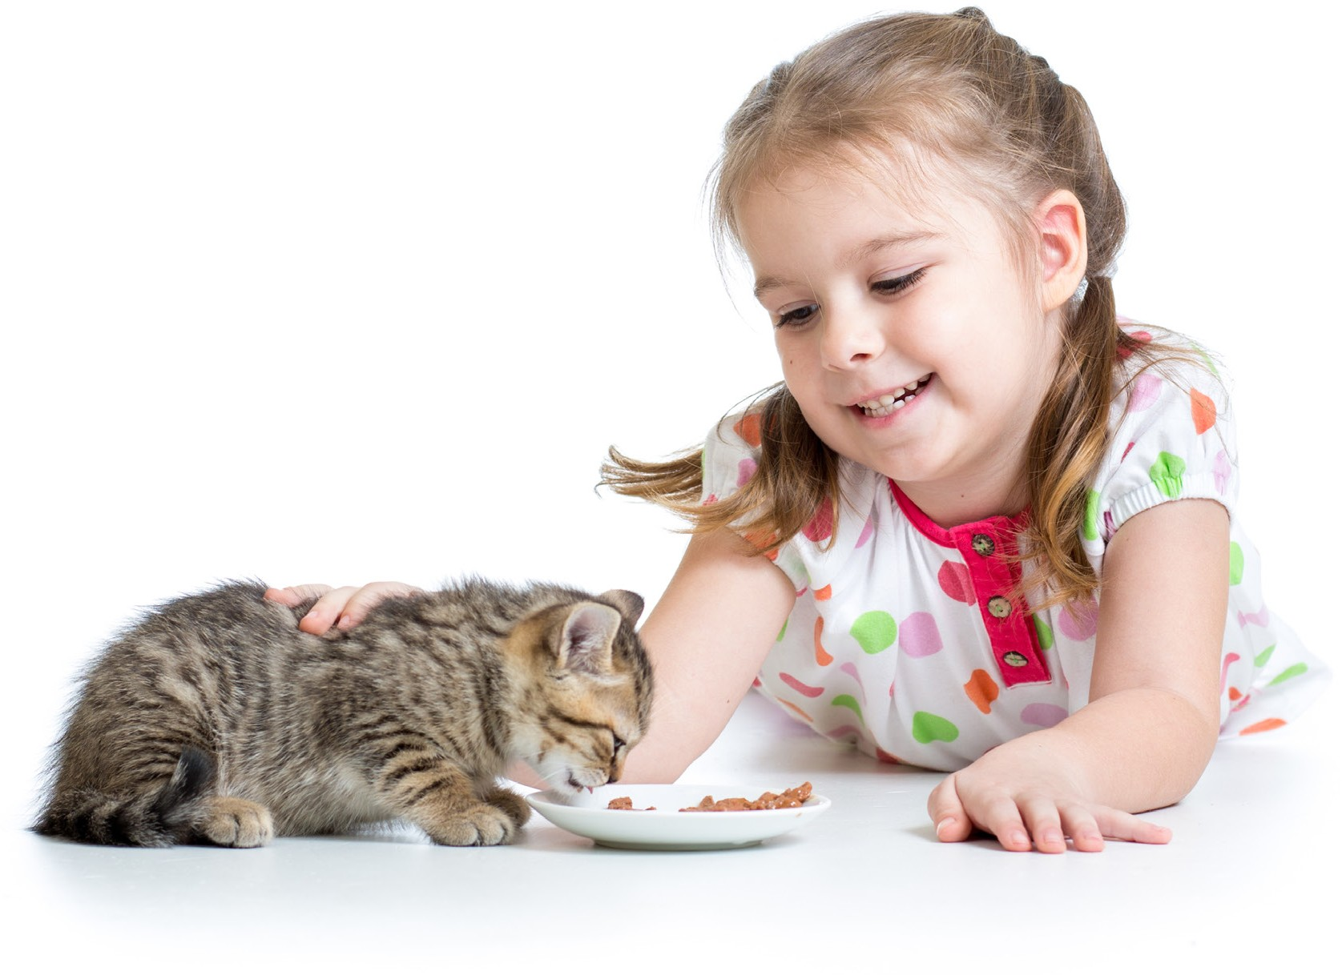
My Family Helps Me Care for Myself
MY FAMILY

Complete the Healthy Me award.
3

- 1. Listen to a story about being healthy.

2. Say 3 things you’ve learned about families.
(Note taking area for teacher/adult care givers)

3. Play an action game about being healthy.

MY FAMILY
My Family Helps Me Care for Myself

4. Complete an art project about being healthy

The World of Friends
MY WORLD


Complete the Creation award.
1

- 1. Sing a song about creation.

- 2. Listen to a story about creation.

3. Say 3 things you’ve learned about creation. (Note taking area for adult care givers)

- 4. Make a craft about creation (Fill in the creation wheel on the next page).

- 5. Complete an activity about creation.

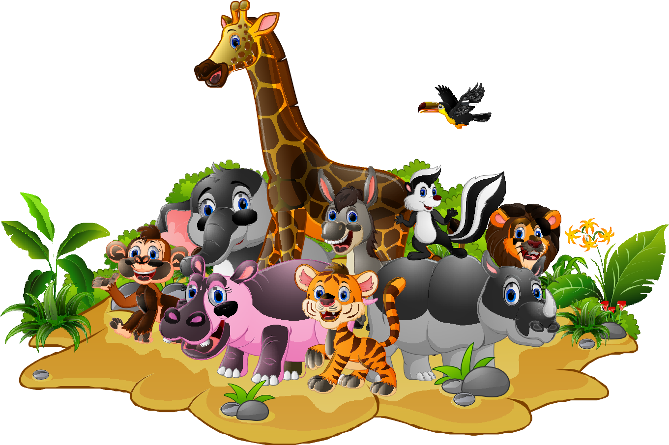

MY WORLD
The World of Friends





































The World of Other People
MY WORLD

Complete the Community Helpers award.
2

- 1. Listen to a story about community helpers.
Book Title:
Author:

Summary:

Date:
Signed:

- 2. Pretend to be community helpers.

Role Played:

Date:
Signed:

- 3. Play an action game using community helpers’ skills.

Game/role played:

Date:
Signed

- 4. Complete an art project about community helpers.

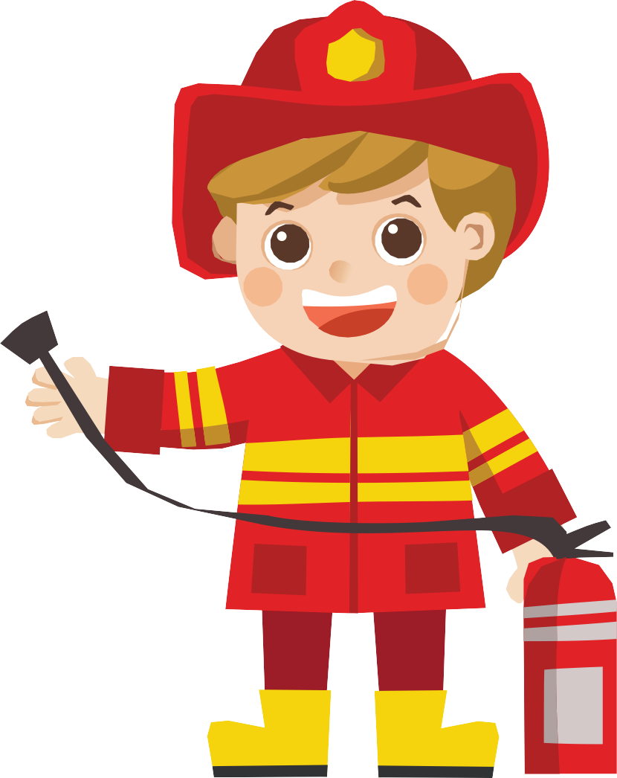

The World of Nature
MY WORLD

Complete at least two of the following Little Lamb level awards:
3

Bodies of Water

Requirements:
- Listen to a book about lakes, streams, rivers, and oceans.
Book Title:
Author:

Summary:

Date:
Signed:

- Sing a song about lakes, streams, rivers, and oceans.
Song sang:

Write a phrase of the song:______________________________________

Date:
Signed:

- Play a game about lakes, streams, rivers, and oceans.

Game played:
Role:

Date:
Signed:

- Make a lakes, streams, rivers, and oceans craft.

Insects

Requirements:
- Listen to a book about insects.
Book Title:
Author:

What was funny to you__________________________________

Date:
Signed:

- Say three things you learned about insects.

______________________________________________________

- Play an action game about insects.

Game played:

Role:

What made you laugh? __________________________________

Date:
Signed:

- Make an insect craft.

Stars

Requirements:
- Listen to a book about stars.
- Say three things you learned about stars..
- Play an action game about stars.
- Make a star craft.
- Sing a song about stars.

Weather I

Requirements:
- Listen to a book about weather.
- Say three things you learned about weather.
- Play an action game about weather.
- Make a weather craft.

Zoo Animals

Requirements:
- Take a trip to the zoo, if possible, or watch a video or movie about a zoo
- What animals did you see?
- What kind of food did most of them eat?
- Did you see any birds? If so, what were they? Name them
- Draw or colour two things you saw at the zoo
- Who made everything you saw at the zoo? Can you find the answer in the Bible? If so, where is it found?














